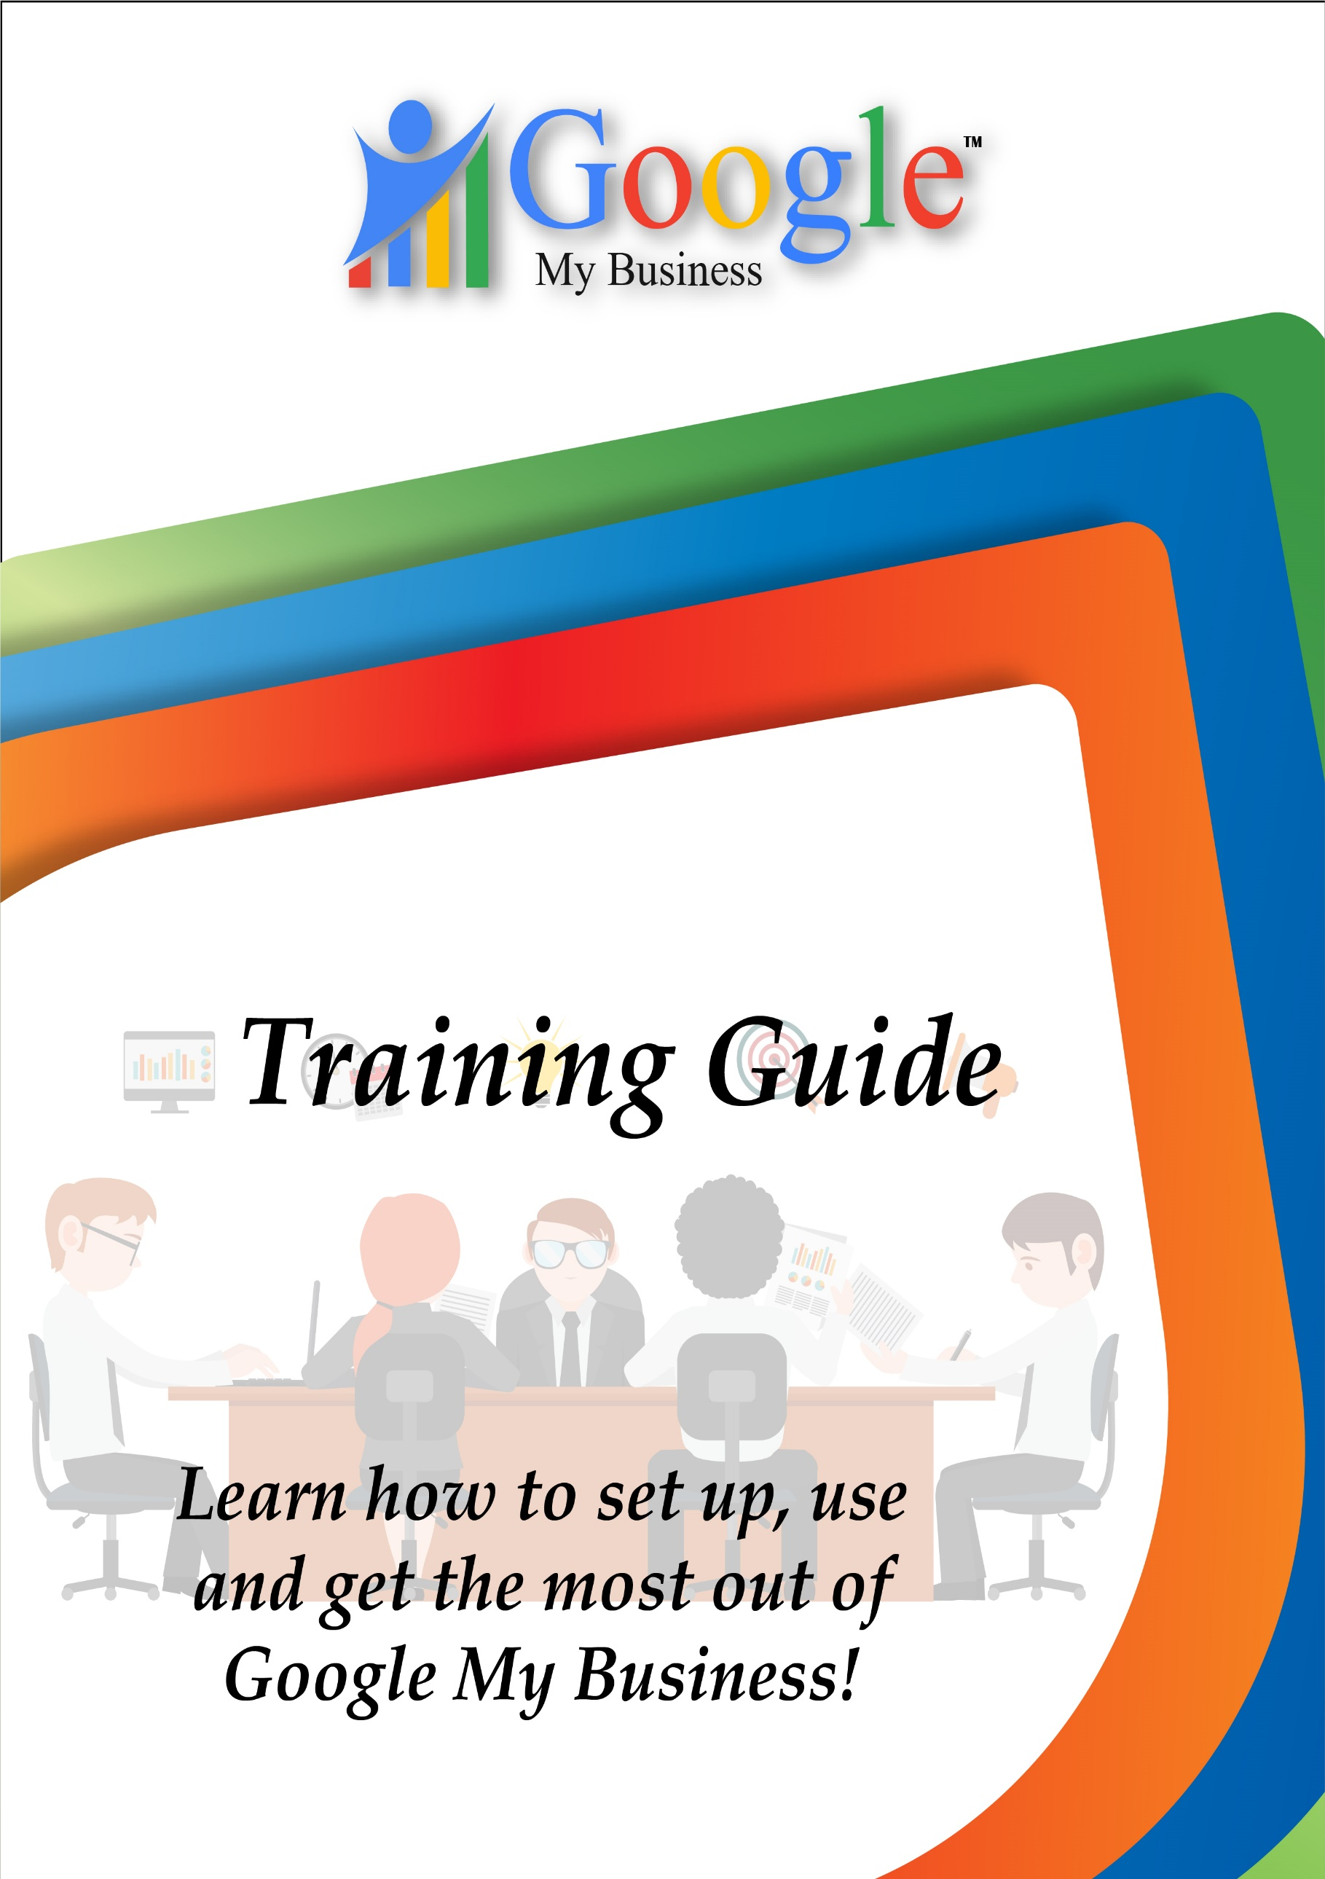
Table of Content
Introduction
Chapter 1. Google My Business: AN Overview
Chapter 2. Getting Started with Google My Business
Chapter 3. The Guide to creating Google Posts
Chapter 4. Tips to improve your local search visibility with GMB
Chapter 5. Google My Business Tips and Tricks: What You Need to Know
Chapter 6. Google My Business Website Builder: Tips and Tricks
Chapter 7. Mistakes You’re Making On Your Google Business Listing
Chapter 8. Google My Business Attributes
Chapter 9. Google My Business Listing Guide For 2018
Chapter 10. Improving Your Local Google Presence With Reviews
Chapter 11. Citations, Review Sites & Tracking
Chapter 12. Tracking Google My Business Traffic Data
Chapter 13. How to interpret GMB Traffic insights?
Chapter 14. All about using the Google My Business API
Chapter 15. Case Studies
Conclusion
Introduction
Four out of five consumers conduct local searches on search engines to try and find the right business to meet their needs. Google My Business can connect your business with customers on the other end of those searches. With just a small investment of time, you can create a free way to attract customers.
As an entrepreneur, you are always looking to grow your business online presence, and having a Google My Business page is vital. Well, if you didn’t agree, you probably wouldn’t be here.
Google My Business is a free marketing tool that connects customers with businesses. By spending a few hours creating an account, you can drastically increase your chances of being found online and collecting revenue.
This guide has been prepared to help you build a Google My Business page, and condition it to create a solid online presence for your business, and subsequently increase your leads and sales opportunities.
By the end of this guide, you’ll be able to set-up a Google My Business page, claim and verify your listings, optimize your page to generate reviews, manage your dashboard, and use insights to gauge the quality of your online presence.

Chapter #1
Google My Business: An Overview
Google Search, Google Maps, Google+ and one unified interface to bind them all. The launch of Google My Business, appears as a seamless solution to the chronic problem of managing your Google presence across various platforms.
The tech giant says it will help small businesses connect with their customers by assembling all their business information from Search, Maps and Google+, and managing them right at one place. To keep it short and simple, the new tool lets your customers find you across Google.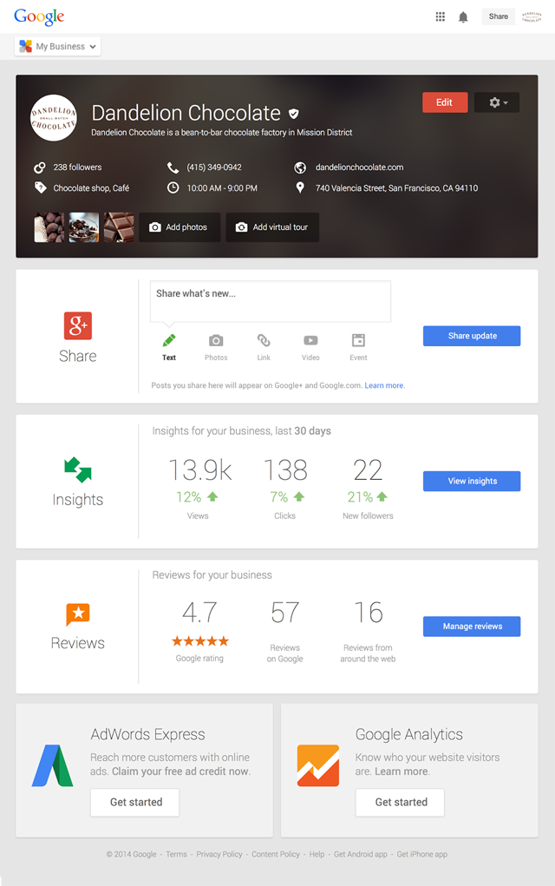
Businesses can post content, track analytics, revert back to customers and launch Google Hangouts all at one dashboard. Let’s have a look at the different sections of the My Business Dashboard separately:
- Business Info Editor: The Business Info Editor contains instructions on 100% completion of your profile. You can update your business information for search, maps and Google+ directly from here. The “View Your Business on Google” option allows you to see how your listing looks across different platforms on Google. Apart from this, you get options for deleting listings, reporting problems and Get Help right at the bottom of the page.
- Insights: The Insights section gives information on- Visibility, Engagement and Audience. You can see the engagement on your posts depending on the content type like, text, links, photos and videos. Information on audience is again broken down into categories like gender, country etc. Some of the data is available only if you have more than 200 followers.
- Reviews: This section shows you the reviews of your business on Google and around the web. You can respond back to these reviews right in the dashboard. Analytics for these reviews are also available in the Reviews section.
- YouTube: Get the engagement information on your videos in the dashboard. You can also go directly to your channel from the dashboard.
Getting Started:
Google says 99% of the Google Places / +Local users have already been shifted to Google My Business. Google took a significant feat of rolling out the new tool globally on the same day to 235 regions with 65 different languages.
How Google My Business Works for the Small Businesses?
- Stay Updated: Businesses can update their information like address, contact numbers, opening hours and more on Search, Maps and Google+ at one place, so that customers can easily connect with them.
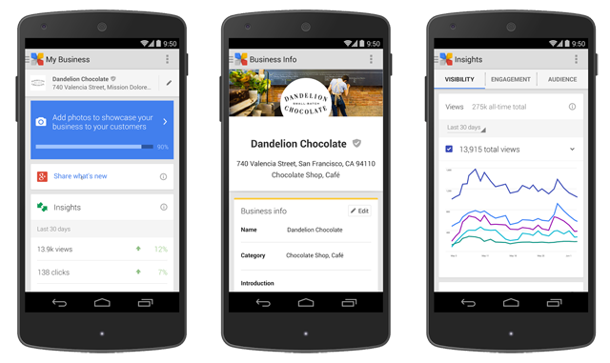
- Tell Customers How Your Business is Unique: You can add beautiful photos and virtual tours of your business to show customers how your business is unique.
- Connect With Customers: Share news, events and other updates from your Google+ page to better connect with your customers. It has become easier to make social updates from within the dashboard.
- Respond to Reviews: Read and respond to reviews and stay on top of reviews from across the web. Google My Business gives a streamlined monitoring of reviews from Google and around the web + review analytics.

- Know How People Interact With Your Business: Use custom insights and integration with AdWords Express to understand how people interact with your business. The Insights are available with more demographic information and data on views and clicks. You can get improved user insights for your business, including visibility, engagement, and audience insights.

- Mobile Optimized: Manage all your business information on-the-go with the android app for the new tool. Google will soon be launching an app for iOS devices as well.
How to Manage Your Google My Business Page:
- In order to make the most use of Google My Business and to connect with your existing and prospective customers, it is necessary to have a powerful social content strategy. Use the Reviews tool to monitor your business reviews and track the ratings for your business over time. This is also where you can respond to reviews as the owner of the business.
- Monitor your Insights and use this to improve the visibility and engagement of your brand. Insights tell you how customers find your business and how they interact with your content by showing you data on different types of views and clicks, driving direction requests and website visits.
- Make the most use of all creative tools and features offered by Google My Business. You can host Hangouts to chat live with your customers, or create photo albums centered on your products, services, customers and staff.
What Has Changed and What Has Not:
Google My Business is now the default dashboard for the users of Places for Business and Google+. This means if you log in to Google Places for Business, you will be directed to Google My Business. However, not much has changed:
Google My Business is just a business listing management dashboard update. No changes have been made to the front end of Google+ Local and Google Maps.
The update has nothing to do with any algorithmic changes. So, it will not change how you do local SEO.
This will bring no changes to the Google Places Quality Guidelines as well.
There will be no changes to bulk uploads. For businesses which have more than 10 business locations and use Google Places Bulk Upload to manage listings, you will find this has been automatically upgraded, when you log in the next time.
Apart from this, what has not changed is the management and ownership of listings, speed of updates and the verification process. However, Google says you should stay tuned in for more updates like faster updates, social features and visibility of live data.

Chapter #2
Getting Started with Google My Business

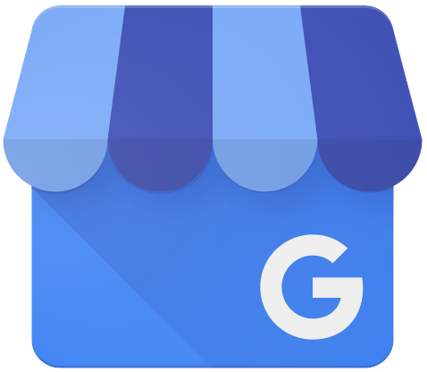
What is Google My Business?
Google My Business (GMB) is a free and simplified dashboard that helps business owners manage and update business listings across the Google Ecosystem. It is a program that was developed by Google for over ten years before its inception in the year 2014.
With several upgrades and tweaks, Google built this CRM feature to help businesses build an online presence that will help users conducting searches to receive not only the basic NAP (name, address, phone number) details, but other kinds of information such as business hours, and specifications as to the availability of facilities such as parking and so on. This is not only an attempt on Google’s side to better its user experience, but it is also focused on helping business owners reach their target audience on online searches.
So, here’s what you can do with Google My Business:
The most important benefit your business can achieve with Google My Business is creating a strong online presence. Aside from creating listings to increase your chances of appearing on searches, GMB also offers data-driven insights about your online presence with added access to Google Adwords and Google Analytics.
Google My Business comes with a review feature that allows your customers to leave you reviews and therefore increases your chances of build better relationships with your customers.
The centralized dashboard is an easy, user-friendly tool that allows you to manage your business information across several Google based platforms.
What kind of business information can you add?
Business name, address and phone number (NAP)
- Website
- Working Hours
- Business Category
- Accessibility
- Google My Business Guidelines
There are some criteria that you need to look out for before you decide to get onboard Google My Business:
- Make sure that your business has a physical location
- Make sure that you are entering consistent and accurate business information
- In addition to this, Google has specifications about the eligibility of businesses to create a page on Google My Business. If your routine business tasks involve interacting with your customers in person during business hours, you are eligible.
- Although they do make an exception for ATMs, video-rentals and express mailboxes. In case you are adding these exceptions to the rule on Google My Business, it is crucial that you add your contact information in the listing to help your customers contact you.
And here’s what makes your businesses ineligible to have a Google My Business listing:
- Business locations that are under-construction
- Rental or for-sale properties
- An ongoing service, class, or meeting at a location that you don't own or have the authority to represent
Ideally, Google has tailored GMB for business owners to ensure the pages are authentic. But they have specifications for authorized representatives like agencies or freelance agents when it comes to creating a business page.
Once you're done creating the account, you can use this Google My Business Guidelines Checker to check your account for any inconsistencies you might face.
Checking For Duplicates
Make sure that you run a search on your business contact information to find duplicates. A simple Google search should do for you to find duplicates.
If you haven't found any inconsistencies, you can carry on creating your page. In case you have found duplicates, or if it looks like someone has already created a page that you haven't, hang in there. You need to continue to a point in the sign-up process that will give you an option to fix this issue. This will be covered in the course of this guide.
Let's get started!
1. Creating Your Google My Business Page
Start by signing into your Google Account by clicking on this link and hit “Start Now.”
Add the required business information in the categories that appears in the prompt window. This is very easy! Here’s what you need to fill out.
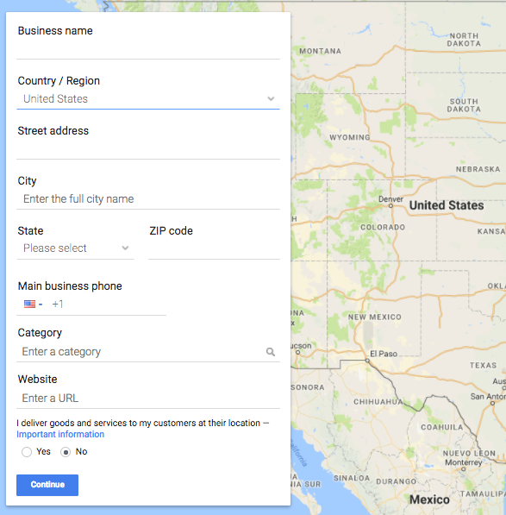
Make sure you zoom into the map, and check the location that is marked. Once you’re done, click on “Continue.”
Do not add any additional information to your business name, like your city or location. Mike Blumenthal, a top Google My Business contributor, says that this is risky business. But as a rule of thumb, do not add unnecessary information in the business name category.
2. Verifying Your Google My Business Page
Now, you’ll be prompted to verify ownership for your business through postal mail, email, a phone call or text message.
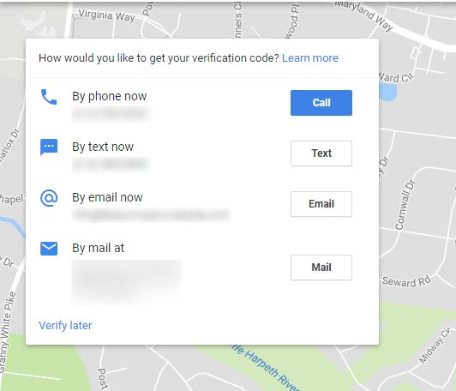
Some of these verification methods are not made available for all types of businesses. Verification by postcard is a little more complicated as compared to the other options which are quite straightforward. So, here’s what you need to know about verification by postcard.
- Post Card Verification
Once you opt for the post card verification, make sure that your business details are accurate. You can have additional contact information just in case you aren’t available when the postcard is delivered. It takes around 12 days for the postcard to arrive and it is vital that you don’t alter any information in your address during this period. Here's what you need to do when you receive the verification code:
- Sign-in to Google My Business
- Go to the ”Manage Location” option
- Click on the “enter code” button on the blue banner
- Enter the 5-digit verification code and hit submit
In case you haven’t received your postcard, or if you have lost it, you can request for a new verification code by following the same process mentioned above. If your business’ website is verified with Google Search Console, you listing can be verified instantly.
After this, you will receive a notification that you’ve verified your business with the given code. Google will prompt you with a window with your business details. Affirm your authorization and hit continue
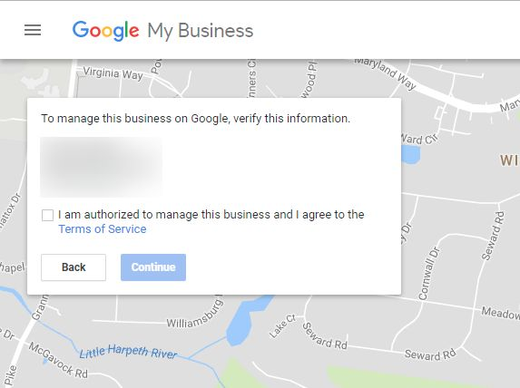
As mentioned before, the other methods you pick to verify your business are quite simple. You will receive your verification code via text message, phone call or email which you can use to verify your business details as mentioned above.
What if your GMB page is already verified by someone else?
This is a common issue when business owners create their Google My Business pages, and it is fixable. There are three ways to go about it:
- Check if your listing was verfied with an older email ID which you'll need to update your page with
- Contact the page owner and request access
- Request access from Google
The first two ways are quite straightforward, and you can do it yourself. Here's how you need to go about requesting Google to claim your business listing
- When you go on to your account, locate your business on the map in the search bar
- Once you've found your business, Google will prompt you to ask for admin access
- Now, Google will prompt you with verification questions that you need to answer about your business
- Google will contact the owner, and request him/her to get in touch with you
- If your request is verified, you will receive management access to your listing page. If not, your request might still be under Google's verification process. In case Google hasn't responded to you within a week, contact Google My Business support again.
- In case you feel like your request is not attended to, you can try tweeting your issue to Google My Business at @GoogleMyBiz.
3. Add Details to the Info Section
Once you get access to your dashboard, make sure you fill out your business details in the “Info” section. This information will appear on search results and the “website” section. Once you’re led to the page, just add the required information in the relevant slots. In addition to your business NAP details, you'll need to add additional information about your store. This includes accessibility information, timings, payment methods, etc.
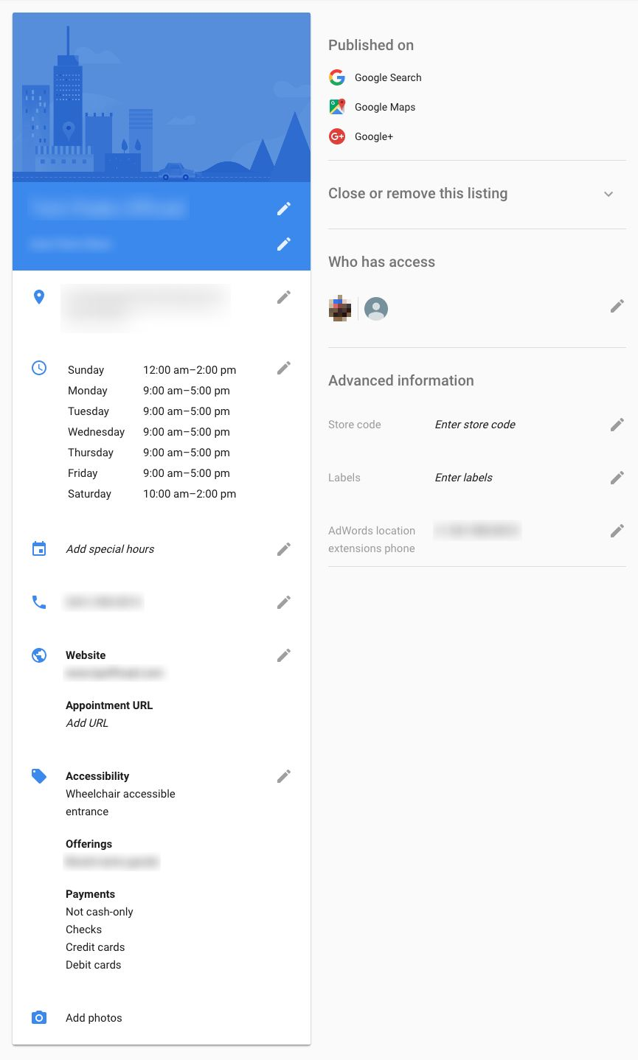
4. Google Posts
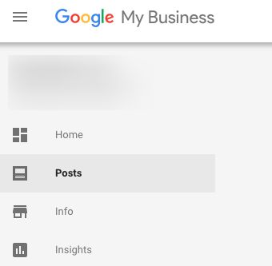
On your Google My Business dashboard you are given the option to create 300 word posts - like your average Facebook status. You can promote events or other kinds of content with these.
- Click on posts in the sidebar:

- Fill up the details about the duration of the campaigns
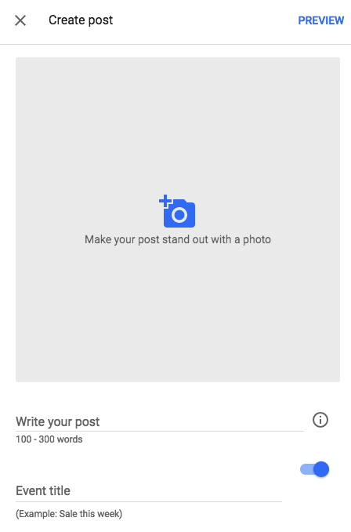
- Add a button that is relevant to your current marketing campaign.
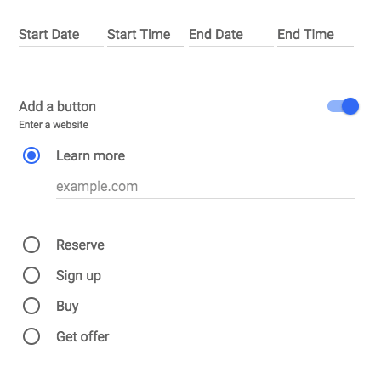
Here are some pro-tips from Joy Hawkins, a top contributor for Google My Business:
- Add UTM parameters for the links you add as the Google posts don’t “naturally integrate” with Google Analytics. Aside from the number of views and clicks that you get with the “insights” from your dashboard, you cannot track any other metrics.
- Aggregating keywords in your posts won’t benefit your rankings.
- The best image size to use is 750x750. Images smaller than 250x250 will not be accepted. In addition to this, other multimedia elements like GIFs and videos can’t be used as they are not supported as of now.
- You need to make the first 100 words of your post description count because that is what appears in the Knowledge Panel.
- The most recent post that you put up will be the first to show on the carousel followed by the previous ones that you created.
- These posts don’t get indexed by Google.
- Google doesn’t allow a post to stay for longer than seven days.
5. Adding Photos of Your Business Location
Adding photographs to your page will help users get a better idea of your business. Businesses with photos in their online pages get 35% more clicks than businesses without photos. Many businesses fail to recognize the effectiveness of adding photographs. These pictures will be displayed alongside the map after your business is clicked on in the search engine results page.
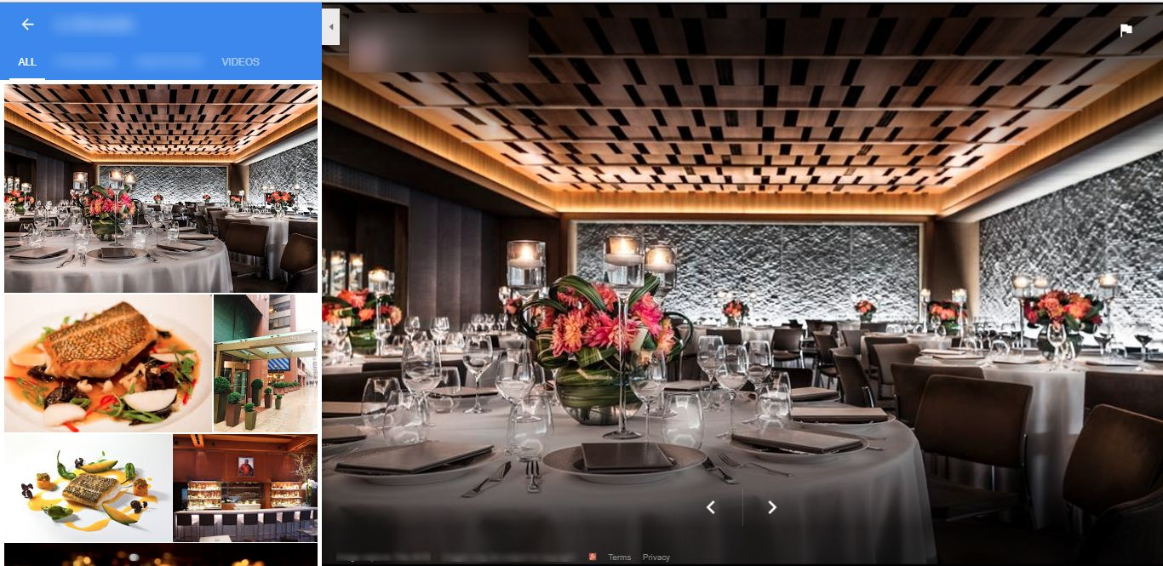
Google My Business requires you to add different kinds of photographs to enhance your business listings. Here are some of the photos you’d need to upload:
- Make sure that your Page Photo is one that will leave a good first impression. It needs to be something needs to stand out, so, make sure you check your competition. Don’t just make it your logo. The picture should have a 250 x 250 resolution.
- When you upload your Cover Photo, it will be displayed in your Google+ business page. The ideal image resolution for this Google My Business is 1080 x 608
- When you upload your logo image, make sure that is of a 250 x 250 resolution.
- You can even upload a Preferred Photo that will be displayed alongside your business name on Google search and Google Maps.
- By uploading Exterior Photographs, you can help your customers find your store. Think of it as an extension to the your address details. When you take pictures for this purpose, make sure that you cover every direction of your street.
- Interior Photos are pictures of the inside of your store. The best thing to do while taking these pictures is by imagining what it feels like for a customer inside your store.
- Similarly, add Product Photos and Team Photos to your page as well
- Hire a Google Trusted Photographer to take it all the way and ensure that your pictures are in JPG and PNG format.
6. Insights
Google My Business gives you analytics in its insights option. You can track the number of clicks and visits that drive traffic for your business. According to Barry Schwartz from Search Engine Land, you can even find out how your customers ended up on your page on SERPs (search engine results page) through direct and discovery.
Direct refers to a user who searches specifically for your business information online. Discovery refers to a search that organically leads a user to your page because of the information on your business category, product or service. And lastly, you can even track the number of phone calls you receive from your listing with insights.
You can adjust the date range to get the data from a specific period, and similarly, you can focus on a certain area to find specific information. This year, Google even rolled out a newer email feature that sends out periodic emails with data about your performance on Google My Business.
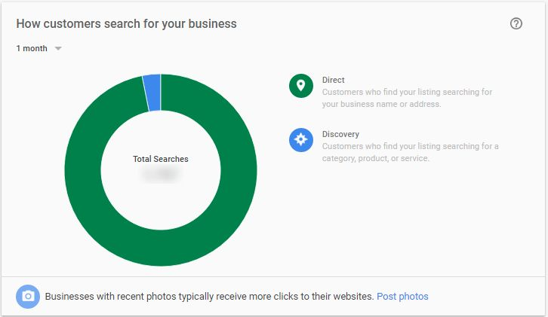

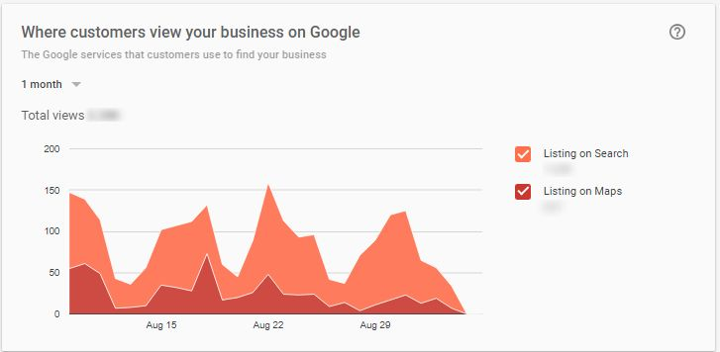
7. Creating a Website with Google My Business
The website builder feature was rolled out by Google recently to help businesses create websites by themselves. The feature is mostly free, although it will cost you to get a custom domain - that is, a .com, a.biz or .net site, - from Google Domains. It is best to purchase a domain as it will turn out to be SEO-friendly, and it will be memorable to consumers.
In addition to this, the website feature is mobile-friendly, has automatic updates, and has simple provisions to help you place ads on your site.
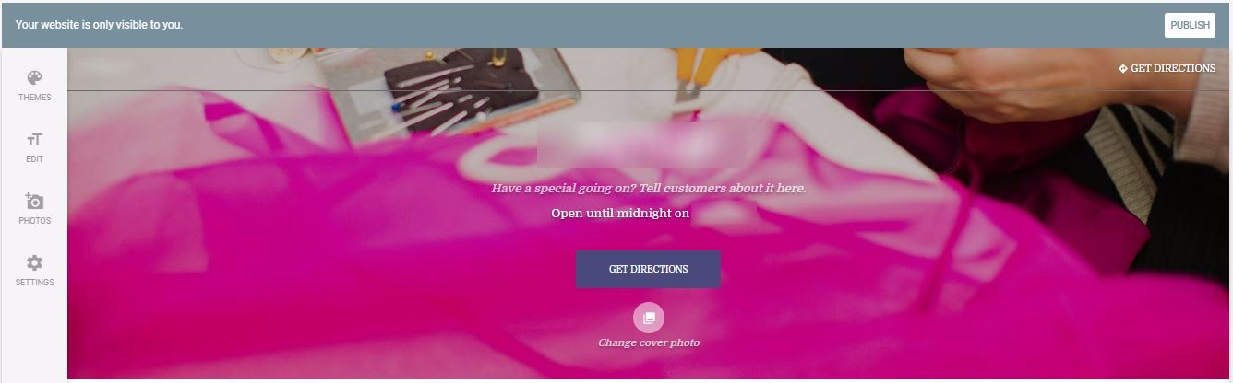
- Creating a website with Google My Business is quite simple. You will find the feature in the hamburger button (the three horizontal lines on the top left-hand corner of the page).
- From here on, Google will prompt you with to create a website, instructing you in a step-by-step process.
- You can edit the website layout with themes and website content - headline, body description, and add photos for your cover picture and gallery.
There site is a straightforward, user-friendly, simple one. Although, it is far too simple. It lacks social sharing buttons, doesn’t allow you to add CTAs, and doesn’t have an integration with analytics (which means you need to solely rely on Google My Business Insights).
In addition to this, the site doesn’t allow you to add structured data markup, and by extension local business schema. But it is a good option for businesses that cannot invest in creating a website.
8. Managing Reviews
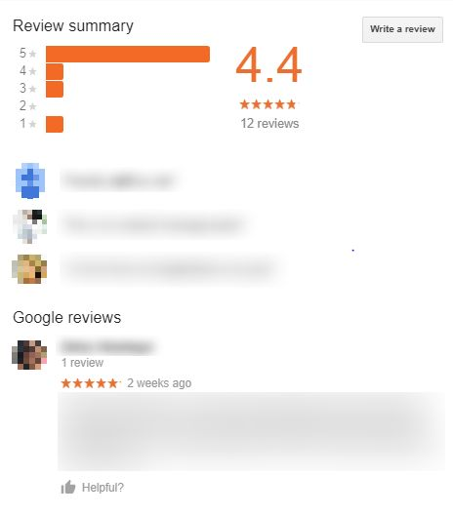
Reviews are important and Google understands this! You don’t need any convincing when it comes to online reviews and what it can do for your business. According to a recent study, 84% of consumers trust online reviews over personal recommendations. It goes without saying that your online reputation needs to be good, and helps consumers make purchase decisions.
Google My Business has a simple set-up for managing reviews. Here's what your reviews appear on searches:
Essentially, when your business appears on SERPs, this is how your information is represented among users. There are two things you need to keep in mind: generating reviews and managing the reviews that follow.
In order to make sure your customers leave you reviews, try these tips out:
- Use a review handout generator
- Use review widgets
- Just ask. According to research, seven out of ten consumers will leave you a review if you ask them.
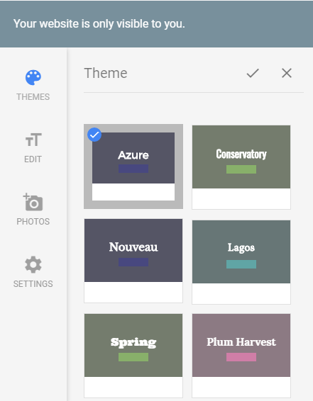
- Responding to reviews is very important. Make sure that you respond to all kinds of reviews, be it appreciation or criticism. In case you have received negative feedback about your services, make sure you respond tactically.
- Make sure that you aren’t defensive when you respond, and leave your contact details so that the reviewer can get in touch with you for further resolution of the problem.
Conclusion
Here's everything you need to do to create a page on Google My Business. It is very effective for businesses to establish a good online presence. By creating a page with Google My Business, you're essentially making it easier for your customers find you through both direct and organic searches. Google is meticulously working to build this tool to make it more efficient and intuitive to give its users a holistic experience in finding information.

Chapter #3
The Guide to creating Google Posts
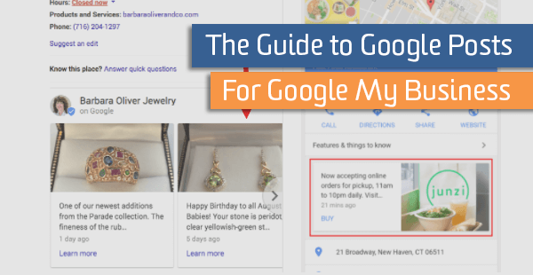
Share events, products, and services directly in Google Search and Google Maps with Google Posts, created through Google My Business. Google Posts are small cards that appear within the knowledge graph in Google Search Engine Result Pages (SERPs) when users search for your business.
These cards are great for promoting timely content to customers at the right time and are managed through an intuitive interface inside of Google My Business and can be added for each business location.
Different Posts for Different Folks
- Posts can be used to share a variety of information like:
- Events such as a brunch band or an in-store session
- Offers/specials such as sales and coupons
- Product updates such as new merchandise
- Announcements such as “Open late this Saturday” or “Special guests this week!”
Why Google Posts?
Google Posts are a quick and easy way to enhance the experience for people that are searching for your business. Not every business will have a use case for it, but the ease and simplicity of setting up Posts encourages experimentation and testing to see what works for your company. So why give them a shot?
- It’s FREE
- Using Google Posts to promote your business in organic results pages costs nothing. Think of it as a Facebook post, but with a much wider reach. Why wouldn’t you try it?
- Most Purchase Research Starts in a Search Engine
- 81% of shoppers conduct online research before they make a purchase. 60% begin by using a search engine. Posts gets information in front of those people at the right time.
- Incentive to Click
- Posts offers users a one-click incentive to learn about, buy or sign up for a product, service or event.
- Easy to Manage
- Posts is part of Google My Business and can be managed from the website or on-the-go with the app.
Where Posts Show Up?
When you share a Post, users will see it in Google SERPs and Google Maps when they search for your brand. They will appear in the knowledge graph to the right side of the search results on both mobile and desktop. You can see an example in the images in the first section of this blog post.
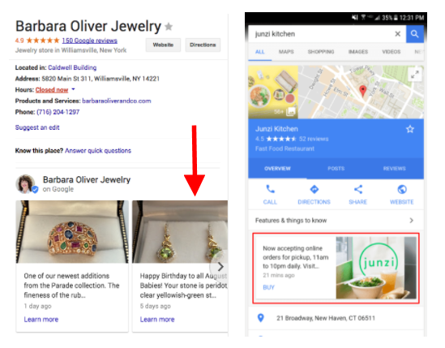

How to Create Posts?
It’s easy to create posts from your computer or on the go. Download Google My Business on Android and iOS.
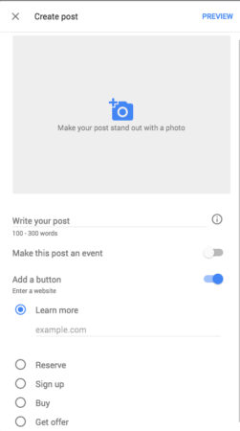
Desktop
- Sign in to Google My Business. If you have two or more locations, click Manage location for the location you’d like to manage.
- Click Create post. Or click Posts from the menu.
- The “Create post” screen will appear. Here, you’ll see options to add photos, text, events, and a button to your post. Just click each field, and enter the relevant information.
- Once you’ve created your post, click Preview to see a preview. If it looks good, click Publish in the top right corner of the screen.
- Your published post will appear in SERPs within a few minutes.
- All posts will be archived in the Posts tab.
Mobile
- Open the Google My Business app. Download Google My Business on Android and iOS.
- In the bottom right corner of the screen, tap the create icon (the one with the plus sign). Then tap the posts icon that appears.
- The “Create post” screen will appear. Here, you’ll see options to add photos, text, events, and a button to your post. Just tap each field, and enter the relevant information.
- Once you’ve filled out your information, you’ll see a preview of your post. If it looks good, tap Publish in the top right corner of the screen.
What You Need to Know
There are a few need-to-knows that are helpful to cover upfront.
- Google deletes your post after 7 days to ensure the sharing of fresh content.
- Event Posts stay live until the event is over.
- The first 80 characters are what shows up in the Knowledge Panel.
- Your newest posts will show first and the older ones will be displayed in a carousel.
- Google will scroll up to 10 posts in a carousel but only the first 2 are seen in SERPs.
How to Create Amazing Posts
The tips to make a great post are similar to making any other type of advertisement, just with different limitations on size and characters. The basics are outlined below.
- Explore and steal ideas from blogs like these or from other Posts you see showing up for businesses that attract your attention.
- Use Great Photography
This may seem like an easy one, but use a clear, well lit photo so your post stands out.
- Image format: JPG or PNG format
Minimum size accepted: 720px wide by 540px tall

- Write Actionable Headlines
- Write the headline to inspire action. Something like “Get Your Free Coffee” ensures that headlines are comprehensive and quickly let the user know what you want them to do.
- With a limited number of characters, this is a great place to reuse some of the skills you may have learned writing ads.
- Keep Descriptions Short and Sweet
- Keep the post brief and includes only necessary details. You have 1,500 characters, according to Google, but only the first 80 show up in SERPs. Make it count.
- Best practice: 150-300 characters. Although, about 80 characters (including the headline) show up in the knowledge graph.
- Use a clear call-to-action: “Order now” or “Learn More” or “Get Free Download.” With such high-turnover on Posts, you’ll have lots of opportunity for experimentation.

What Not to Do in Google Posts?
- Don’t Use Commercial Slang
For example, “BOGO: 50% off kids backpacks” is not ideal. Going back to the previous section, make sure your posts are comprehensive. Those of us who don’t shop much might not know what “BOGO” means.
- Don’t Use Excessive Exclamation Marks or All Caps
Google recommends against using headlines or descriptions that use too many exclamation marks or all caps. “Amazing SALE Monday!!!” is a great example of Post to avoid.
- Don’t Include More Than One Theme/Offer in a Post
Keep it simple. Don’t try to cram all of your offers into one Post, like this: “Half price coffee and donuts from 3-6 PM on Fridays, and buy 6, get one free donut on weekdays.” You can publish 10 Posts at a time. If you have more than one offer, use another Post to call out the second offer separately.
- Don’t Craft a Deal With Too Many Exclusions
No one is going to click your Post if there is too much exclusion. Put your offer in the post and share the exclusions on the page.
How to Measure Engagement/Success
Google offers Insights on posts including impressions and clicks, but Posts doesn’t integrate with Google Analytics.
To measure the success of your Posts, use Google’s URL builder to create a unique URL with your CTA button. This allows Google Analytics to gather more information about the user and if they’ve engaged with the website or converted after clicking the link from your Post.
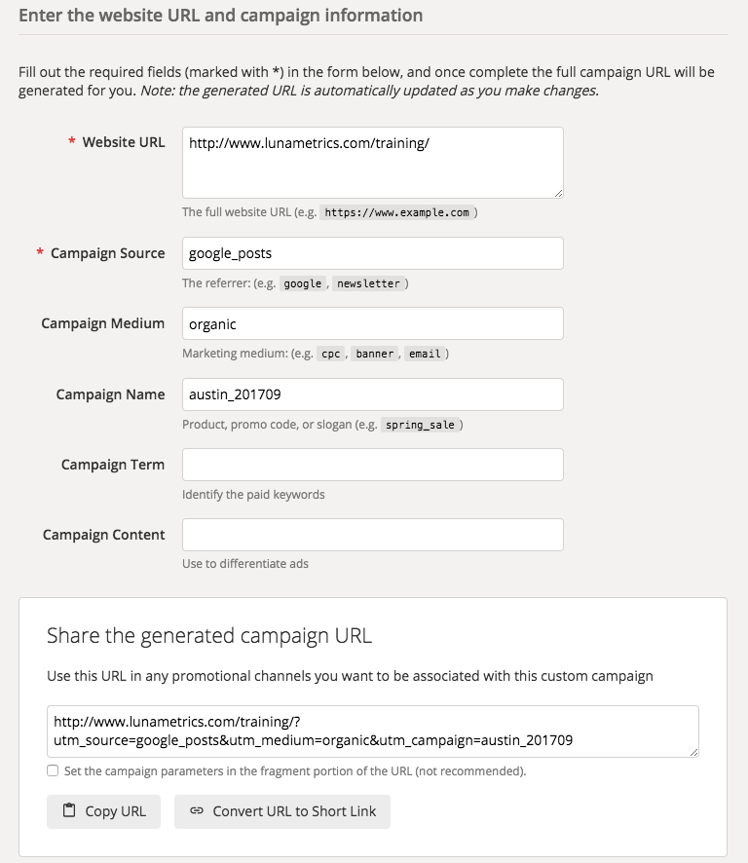
Conclusion
Using Google Posts will provide an avenue to get relevant, timely information in front of users at the right time. By using a custom URL, information about users who click on Posts will be pulled into Google Analytics and can be used to make marketing and advertising decisions.

Chapter #4
Tips to improve your local search visibility with GMB
Where to go next with your Google My Business listing
So, you've set up your Google My Business listing but still aren't seeing results. What's the next step? Here, we lay out some suggestions to further optimize your listing for better local search visibility.

GMB optimization has quickly become something of a cottage industry within the broader scope of SEO. By now, you’ve probably heard all about the importance of keeping your listings up to date with accurate store hours, phone numbers and addresses. Those are the no-brainer changes. How do you go beyond the low-hanging fruit to really make your GMB listing stand out?
Some relatively straightforward tweaks to Google My Business can have a profound effect on your listing’s visibility and your local pack ranking. They may seem deceptively simple, but these GMB hacks could make all the difference in the world.
- Address standardization
OK, so you’ve updated your store listing with an accurate address — but does it follow recognized and standardized guidelines? Any irregularities within your GMB listing could adversely affect your local ranking.
Compare your address with the acceptable formatting and standards laid out by the United States Postal Service (USPS) and see how it stacks up. It may seem minor, but updating your address to bring it in line with USPS standards will help your local page ranking.
For organizations outside of the United States, be sure to check with your national guidelines on address standards.
- Geocode precision
Google My Business uses your listing address to generate geocodes, which in turn dictate where your store appears in Google Maps. This is not a foolproof process, however, and it’s not unheard of for businesses to have wildly inaccurate geocodes. Google Maps could put your store at a nearby intersection, or even several blocks away from its actual location.
You don’t want to make it any more difficult for your customers to find you, which is why it’s so important to ensure your listing has precise geocodes. This is doubly important for any business located in a larger metropolitan area. Denser areas could see more inaccurate geocodes, so city dwellers need to be extra mindful of this factor.
- Listing categories
Google doesn’t change its algorithm for the fun of it. The company is always trying to improve its search engine so it returns results that closely align with users’ queries. With each new update, relevance becomes an even more important factor in a listing’s visibility.
The more precise you can be with your store category, the more likely your listing will appear for searches that match it. Don’t settle for overly broad store categories, even if they are technically accurate. Drill a little deeper to provide an accurate characterization of your business, and you’ll likely see better results.
- Proximity to search
That same need for precision applies to your store’s listed location as well. It may be tempting for businesses located near a larger city (but still outside of it) to list that metropolis as their location. Why not, right? It could broaden your potential customer base.
Google takes location and proximity into account when calculating local page ranking, however. It won’t be fooled by businesses misrepresenting their location, and if anything, doing so will hurt those stores’ visibility. If your shop is in Skokie, Illinois, say so. Don’t pretend it’s located in Chicago to draw more eyeballs. You’ll be far more likely to rank for searches done in your area.
- Cultivate (and respond to) reviews
Unknown quantities tend to scare off consumers. No one wants to be the first diner at a new, non-vetted restaurant or roll the dice on a barber with no track record of leaving customers satisfied with their haircut. More than ever, online reviews are critical to local page success. Encourage your customers to go online and leave a review for GMB to pick up on. The more reviews you have, the more exposure your business can get.
- Create engaging content
An inactive site could be mistaken for a dead one. One area of optimization that’s easy to overlook is filling your site with engaging content. Creating new material to share with regular or potential customers is a good way to improve your local page ranking. Moreover, content that focuses on local events or area-specific concerns can help your search efforts immensely.
Additionally, consider making use of Google Posts, which allows you to publish events, promotions and other business updates directly to Google Search (in the Knowledge Panel) and Maps.
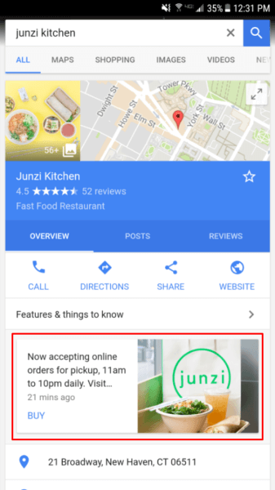
A recent study by Joy Hawkins and Ben Fisher suggests that use of Google Posts may have a mild impact on ranking.
- Add relevant images
A picture says a thousand words, yet many stores neglect to include images in their Google My Business listing. Customers today like to do their online legwork before visiting a business and actively look for photos of products, store interior, signage and so on.
Uploading images can have a profound effect on your local ranking.
- Optimize those listings!
The beauty of it all is that none of the suggestions above are very time-consuming. It’s pretty easy to make some quick optimizations to your Google My Business listing and website that have the potential to increase online traffic.
It is critical you begin by adding your companies listing on Google My business. It is the first step to being found in Google local search results.
Proper optimization is the next step.
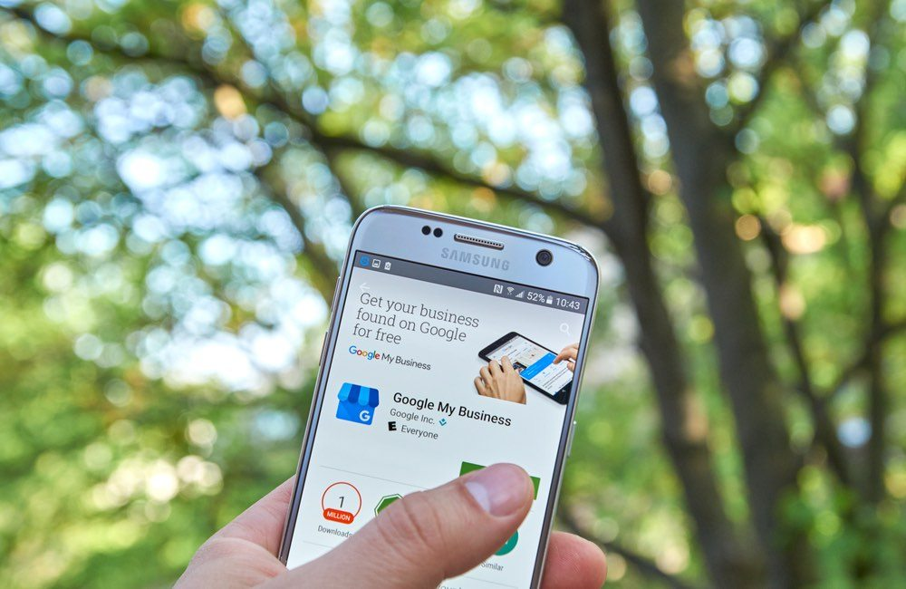
Having an optimized listing could mean that you gain an advantage over your competitors. The goal here is to stand out from the crowd, have your location found.
Steps to optimize your business listing
First things first, you need to learn how to maximize your page step by step. Here’s how:
1. Using the 3 Pack and Local Search – Have you noticed, that when you search for a local place to eat, a list of restaurants that are related appear at the top of Google’s results?
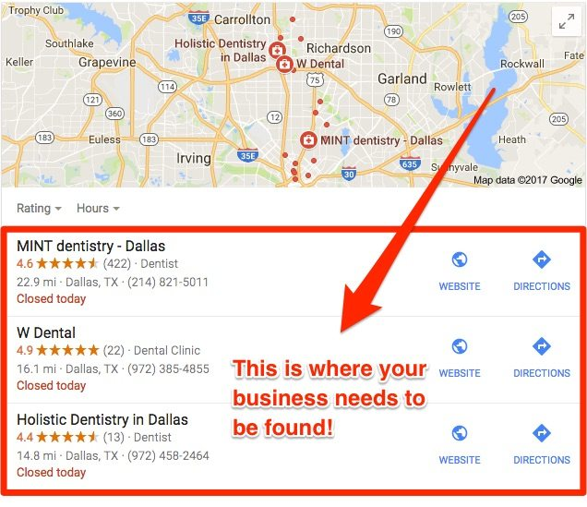
This area is called the Google Maps 3 Pack.
So you want to appear higher on google maps.
If your local business is listed on GMB, it will display in the maps when someone searches for your keywords. Well, only if your SEO and optimization are done well. Where you rank search though is dependent on multiple factors.
So, you may be asking what does this have to do with you?
For one, the companies that are found toward the top, are those that get the most clicks. These are companies that have done a great job of optimizing their location as part of their SEO strategy.
With a little work, you can improve your ranking on Google Listings and get ahead of your competition.
2. Make sure to add your name, phone number, and Address to your website
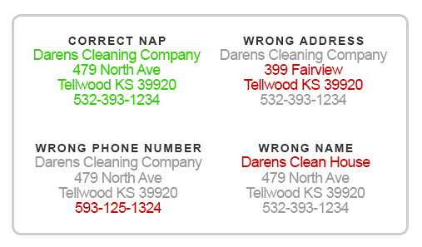
NAP is vital for Google My Business Optimization
You may think what does your name, phone number, and Address has to do with your rankings. How are people going to find you if your information is inconsistent?
In case you didn’t know, your site’s ranking is a significant factor for improving your placement on Google. In other words, you want people to find you.
Your company information will be the first thing that customers will want to look for. Since Google’s algorithms are becoming more advanced, search engines don’t rely on keyword information anymore.
This is why your primary company information is essential. This is the first piece of information that your customers will look for. If for example, you own a salon with branches in different locations, create a separate page for them on your website which includes the necessary information.
It will be even better if you can include a Google map for each page as well. The same goes for other services as well.
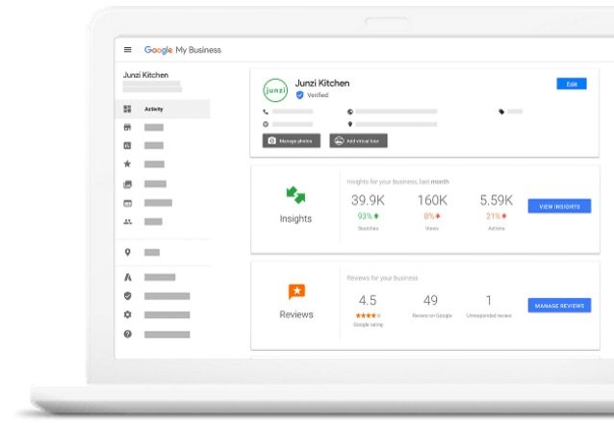
3. Add your business information to your listing
This step should be self-explanatory for a good reason.
But even small details like these matter considerably for successful listing optimization. As mentioned above, you should first add your business information.
When it comes to listing your phone number, it will be helpful to include your local number, not a tollfree number.
Also, make sure that you add as much information as you can about your local business as possible. This includes your hours of operation, years in operation, and your internet address.
4. Add quality relevant images
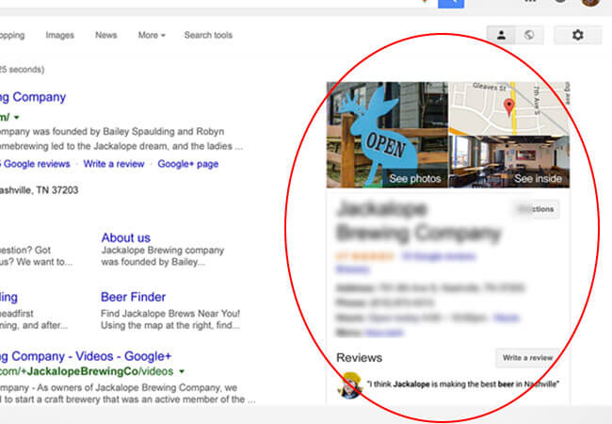
When it comes to business listings, images are significant. If you think you can get away with just adding one photo, no way.
Images make a big difference in click rate. Taking the time to upload several high-quality photos to your listing will improve your page.
Post flattering photos as your exterior and interior of your location. These images will help your customer imagine the look and feel of your local business, which is very important.
You also have the option to add images of your team members, location, products, area, menu items (if you own a restaurant), and other relevant information.
5. Google My Business Benefits of Categories
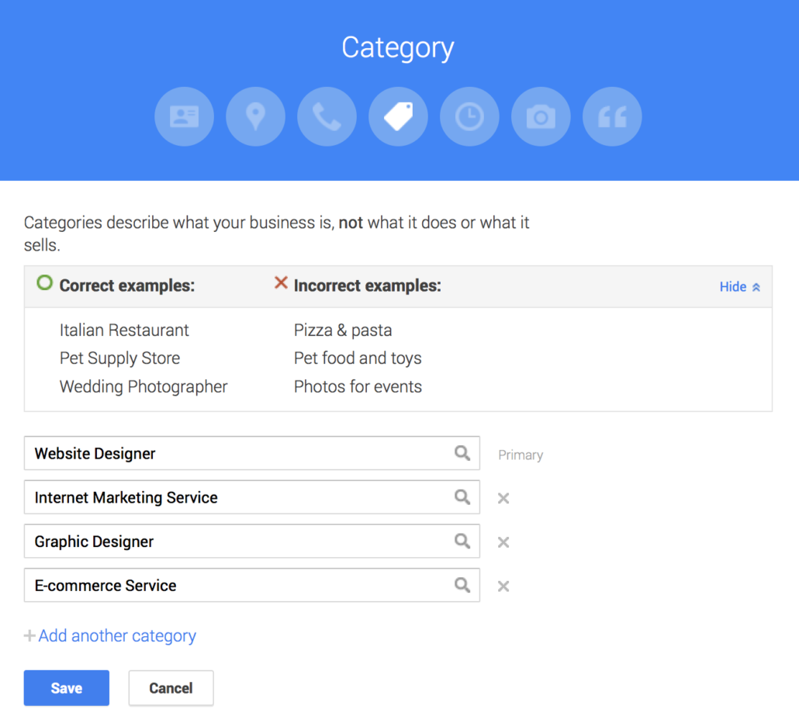
Many people will often overlook the importance of categories in business listings. In case you didn’t know, they are another essential piece of the puzzle. The problem is, most companies fail to include categories or worse choose completely incorrect ones for their business in general.
Be specific and make sure to include every detail of the products and services that you offer.
You also want to make sure that you make use of the right categories. This is because Google uses this as a basis to list local search results.
So, if you end up using all the wrong ones, your business won’t be included in the recommendations. From my experience, limit your use to 2-3.
6. Make sure you get reviews
The more positive reviews you receive from customers, the more reputable your business will be. Keep in mind, that reviews are a Google maps ranking factor for the local three pack.

Even better, Google allows you to ask for reviews from your customers. You should start asking your clients to leave reviews for you, especially if you are just beginning. You can include a review option on your listing page.
Better yet, why don’t you make your review link? Or ask them before they leave your location.
Try out these tips to optimize your Google My Business Listing
GMB listing is an excellent tool to use, especially if you are trying to get your brand exposed. It plays a huge role in determining your position in search engine results as well.
If you are persistent enough, you can move ahead of your competition and gain success. Hope these tips on optimizing your listing help grow your business.

Chapter #5
Google My Business Tips and Tricks: What You Need to Know
Google My Business has come a long way from the comparatively basic version we saw when it first launched. With the addition of new features, and access to valuable insights, it has evolved from being “nice to have” to “must have.”
In this section, we will go over the updates rolled out to Google My Business over the past few years. By the end, you’ll be fully up-to-date on what you can do with GMB.
Google My Business: Latest Updates and New Features
- Google My Business Introduces Photo Galleries
When Google My Business first launched in June 2014, it barely had the ability to display photos. It would take the cover photo from your Google+ business page and use it as the only photo displayed in search results. In February 2015, Google not only introduced the option to customize the photo displayed in Search, it introduced the ability to add multiple galleries of photos. Now you can upload identity photos, interior photos, exterior photos, photos at work, team photos, and any other additional photos you want to show off.
- Mobile App
In September 2015, Google released a mobile app for editing your Google My Business listing. The app is available for Android and iOS, and gives business owners the ability to add, edit, or delete information. You can also use the app to upload photos on the fly, which is incredibly useful since there’s likely more phones being used to take pictures these days than actual cameras.
- More Options for Business Hours
In November 2015, Google My Business introduced the option to set “special hours” for your business. For example, if your business is closed for a holiday, you can set special hours indicating your business is closed on that particular day. Setting special hours will indicate in search results that your business is closed on a day when it would otherwise be open.
- Close And/Or Reopen A Business
In December 2015, Google My Business made it possible to mark a location as permanently closed. With a location being marked as permanently closed, searchers who find your listing won’t end up visiting your business only to find out it’s no longer there. The change isn’t actually “permanent,” however, as there is also the option to reopen a business listing should things happen to change.
- Google My Business Introduces Analytics Insights
When we said GMB was basic when it first launched, we meant it. It didn’t even have analytics functionality, which meant business owners had no idea how much traffic their page was getting. It wasn’t until August 2016 that Google rolled out analytics for GMB. That means business owners can now see how many views their page is getting, where visitors are coming from, and how they discovered the page.
More specifically, in addition to overall traffic, business owners can now learn how much traffic is coming from Google Search and how much is coming from Google Maps. GMB insights will also track how many people found your page by searching for your business name, and how many people found it by typing in a related keyword.
- Multiple Owners for One Listing
In September 2016, Google introduced the ability to add multiple owners to a single Google My Business listing. Current owners of a listing can send invitations to others and designate them as either an owner or a manager. The key difference between the two roles is an owner has the ability to add other owners and/or managers, while managers cannot.
- Bulk Editing of Business Information
In November 2016, Google My Business rolled out an improved editor that includes the ability to bulk edit multiple listings. This feature is available to people who manage 10 or more listings. Bulk editing is accomplished in two different ways. You can either download a spreadsheet of your locations, edit information as necessary, and re-upload the spreadsheet. Or you can edit multiple listings from the GMB dashboard by clicking the checkboxes next to the locations you want to edit and clicking the pencil icon.
- Email Notifications
Also in November 2016, Google My Business added the option to receive email notifications. Business owners can now receive notifications when customers upload new photos to a listing or leave a new review. Notifications can also be sent whenever Google rolls out new updates to the GMB platform, and Google may also send notifications reminding business owners to keep their listings up to date.
- Insights for Photos
In December 2016, photo insights were added to Google My Business. With this addition, business owners can now see how many views their photos received over a period of time. In addition, photo views can also be compared against “businesses like you.” Now you can see how your photos are faring against competitors. Google doesn’t list the names of the competitors you’re being compared against, but at least you can get a general idea of how appealing your photos are in comparison to similar businesses.
- Unique Attributes
Also in December 2016, Google rolled out the ability to add unique attributes to your business listing. This could include indicating your location has free Wi-Fi, offers outdoor seating, whether or not it’s wheelchair accessible, or a myriad of other amenities to choose from.
- Virtual Offices Not Allowed for Service-Area Businesses
In February 2017, Google My Business made a significant change to its guidelines. GMB pages are no longer allowed to be used for service-area businesses with a virtual office. That means if you run a cleaning company that services a specific geographic area, for example, you can’t create a GMB listing if you run the business out of your home. GMB listings for service-area businesses can only be created if the business has a central office that is staffed during the specified business hours. If you feel like this is unfair to businesses with virtual offices you’re not alone, as the change created a lot of controversy at the time.
- Google Makes it Easier to Reclaim Your Listing
In March 2017, Google made it easier for business owners to reclaim ownership of their GMB listing. Small businesses can barely find enough time in a day to run their day-to-day operations, let alone have time for anything else. It’s certainly not uncommon for business owners hand over the reins of their online marketing to an outside agency. Sometimes, if the business relationship goes sour, the agency may refuse to cooperate with the business owner. That could include refusing to transfer ownership of the GMB listing back to the rightful owner.
Previously, if that was the case, it would take a considerable amount of time to resolve the conflict. Google has since automated the process of conflict resolution for GMB listings. Now, business owners can just fill out a simple form. Google will then review the submission and have the issue resolved within 7 days or less.
- Google My Business Starts Reporting on Returning Customers
In April 2017, new insights were added to Google My Business showing business owners how much of their foot traffic is made up of repeat customers. The data is gathered using the same method used to collect the ‘Popular Times’ data. It’s collected anonymously from users who have opted into Google Location History. That means Google is now able to track when the same person visits a location more than once.
- Add Links to Off-Site Attributes
Also in April 2017, Google introduced the ability to add URLs in your listing that point to pages outside of the GMB ecosystem. If you own a restaurant and have the menu published on your website, for example, you can now include a link to the menu in your GMB listing.
- Create a Free Mobile-Optimized Website For Your Business
In June 2017, Google released a free website builder for small businesses that is connected to the Google My Business platform. Having a GMB listing is essential, but it can only take you so far. To get your business to the next level you need to be driving traffic to your very own website. One of the basic expectations of customers today is to search for a business and find their website. Unfortunately, according to Google, 60% of small businesses worldwide still do not have one.
Google is trying to rectify that problem with the release of a simple, one-page website builder. Using the tool, Google will automatically create a website using the information in your GMB listing. From there you can customize it with different templates, as well as add additional text and photos. To be sure, it is not a perfect solution. It lacks many of the elements we believe are necessary for a website to be properly search engine optimized. However, it is arguably better than not having a website at all. Think of it as a stepping stone toward investing in a more full-featured website in the future.
Conclusion
Now you’re completely caught up with everything you can do on the Google My Business platform. As you have learned by now, it is miles ahead of what it was when it was first introduced three years ago. As we said at the beginning of this post, it is a must have for every local business.
Whenever we begin working with a new client, one of the first things we check for is whether or not they have a verified Google My Business listing. If they don’t, we make it our priority to create one and keep it regularly updated.
If you don’t have a GMB listing – what are you waiting for? You have all the resources you need here in this post. If you do have a GMB listing, get the most out of it by reviewing the latest features and ensuring your page is up-to-date.

Chapter #6
Google My Business Website Builder: Tips and Tricks
Google has officially released the Google My Business Website Builder to assist businesses in quickly creating websites.
Google my Business website builder tool is now live in the GMB admin area, just click “website” on the left side menu.
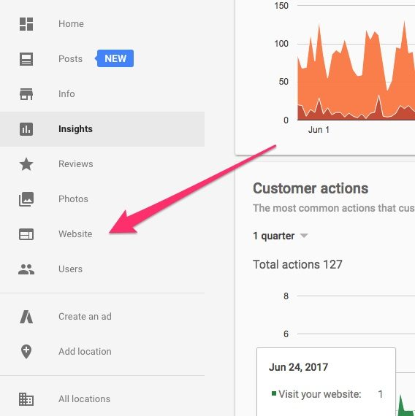
Click “website” in the GMB Admin area

Google has launched a site platform, Google My Business website builder. Targeting small businesses who see an easy platform to create and maintain a website.
Maybe you need a simple website, nothing fancy; this is a great solution.
The new builder by Google has made it so easy; you can create a site within 10 minutes. The only thing needed is to fill in your information and edit accordingly. Maybe you do not have the time to manage your own website, consider asking these questions before hiring a professional SEO.
Here are some tricks and tips to create a Google website:
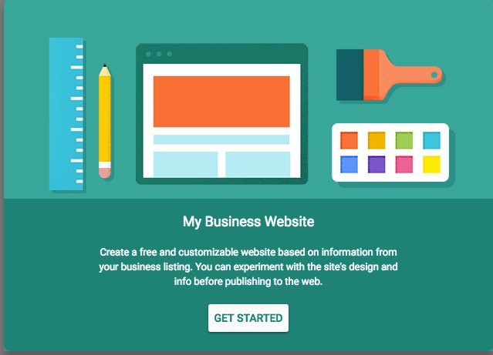

1. Using A Domain With Google Website Builder
The platform and service are free; however, it’s best to buy a customized domain through Google domains. If you don’t, you’ll get an URL that is not so appealing and is less memorable to users, such as yourcompanyname.company.site.
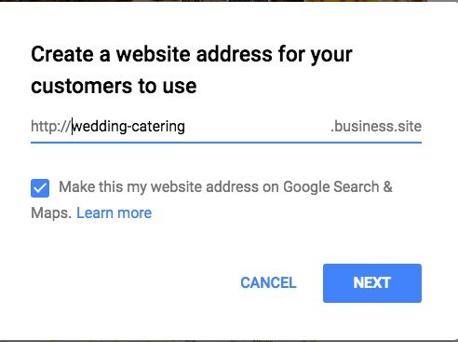
If your budget only allows for a free site, or you want to try out the site builder first, then, obtain a free site. There are still powerful features with this tool to drive more customers to your site, but it’s not as good as a custom site.
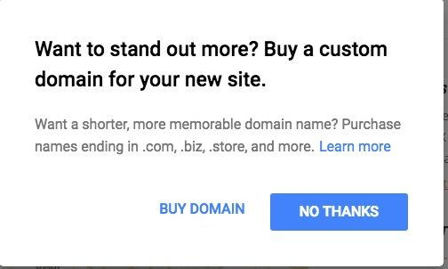
The sooner you start building your site, the sooner you’ll get customers to your site. It only takes three easy steps, including create, edit, and publish. Now that you chose your domain and edit, you can set your site live.
To buy a custom domain, you must click “buy a domain” after you publish your site. The “buy domain” will prompt up when you publish your site. You can also choose purchase a domain through your account’s settings menu.
If you already own a domain name, you can use it for your new Google site. This is very helpful primarily when you are already established with a domain name which appears when searching your business on Google.
You can do this in two ways. One way is by logging in to your hosting business account to choose a redirect link. The other way is by contacting the hosting company to inform them to direct the existing domain to the Google site.
Once the redirection is complete, your existing domain must point to the URL for the new Google site. You can see your new website’s URL, by doing the following:
- Return Google’s website builder.
From the menu, select website.
Create new website account
In the toolbar on the left, click Settings.
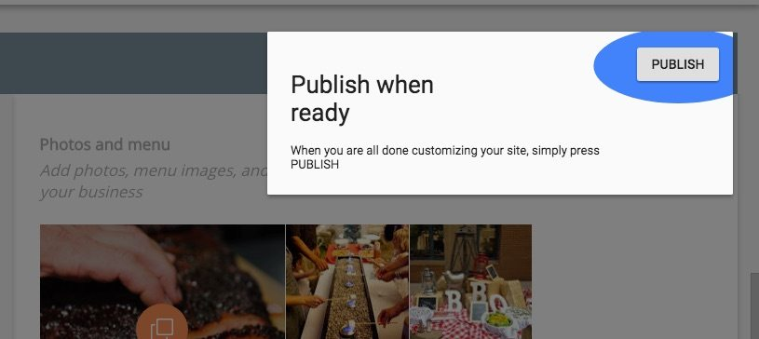
Website finished for your small business.
2. Choose the Appropriate Theme for Your Business Website
There are tons of several theme options available.
You can choose the best font and color scheme for your branding. You also can edit different aspects, such as description, headline, and body content.
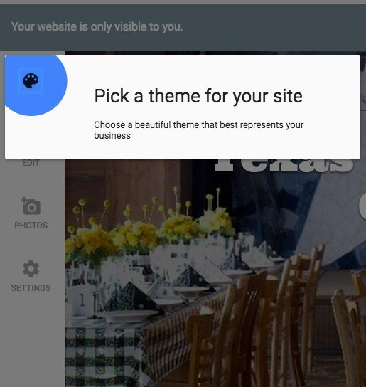
3. Include High-Quality Images, Videos and Virtual Tours of Your Company
Through the site, you can post pictures about your products, staff, infrastructure and anything that might excite a potential customer. Google accepts only two formats of photos to the website: JPG or PNG format. They should have a size ranging from 10 kb and 5 MB. The minimum resolution for the picture that you want to upload must be 720px tall and 720px wide.
Uploading the photo is easy, select the picture and then choose the type of photo and then share to your listing. Your clients and potential customers will see the pictures once they click onto your website. The photos can be a profile photo, a company’s logo, a cover photo or any other photo that can influence the customers when they are making a decision about your business.
As it is to upload photos, it is just as easy to delete them from Google My Business. Sign in to google my Business and select the photos that you would like to remove from your listing. Then remove the photo URL from your gallery. Your pictures will no longer be visible to people who search your business or your product through google search engine. This is a useful tool when you need to change the business logo or when you want to put a more recent and appropriate picture.
4. Information From Your GMG Listing is Automatically Embedded
Relevant information is automatically embedded from your Google My Business listing, such as business hours, contact info, google map, and photos. It is also vital to add other relevant information, as needed, such as special offers.
Stay connected with your customers by sharing news in your Google My Business Listing. Posting timely updates concerning upcoming events, new products, and special offers are essential to staying connected with your customers.
Clients and even potential customers also appreciate when businesses post their hours when the holidays are coming. Many of them appreciate and remember how you took the time to alert them of potential closings or change of hours due to holidays.
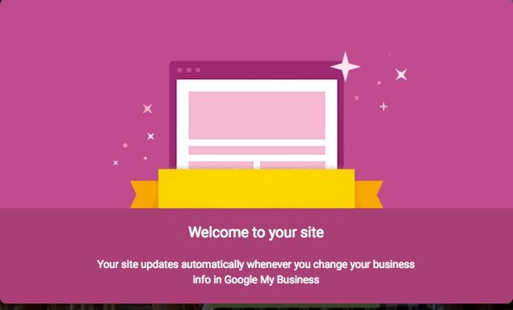
Your site updates with your google my business information
5. Use the Edit Tool To Customize Your Website
This is important because, of course, the sooner you learn to edit, the faster you can change things. The more you learn and know about their edit feature, the stronger you’ll be in editing your site for your full benefit.
When you edit your site, you can customize your design themes, photos, and text.
To edit, you must click on the edit menu to edit text, themes, etc. For text, you start by clicking the blue area within the popup on the left and edit. You can also highlight words to be anchor text to add another site, or Facebook, for instance.
6. Best of All, It Is Free!
Most websites require you to pay annual or monthly payments for web hosting. But Google My Business is free. This means that even if your business is just starting you do not have to worry about the cost of web hosting.
Customers will be able to find you when they search your address name, the product or service that you offer or when they search you through google maps.
Closing Thoughts
With the Google My Business website builder, you can create a site easily and quickly within 10 minutes.
This tool is a free, one-page website that’s perfect especially for those who don’t have time to build a full custom website. You don’t even have to worry about updating as Google automatically updates your information for you from the data from your google my business listing.

Chapter #7
Mistakes you’re Making On Your Google Business Listing
Use These Tips to Gain the Greatest Visibility and Avoid Suspension on Google
By claiming and optimizing your listing correctly, you have the opportunity to show up in the local pack (map) results when someone is searching for a nearby lawyer or law firm. Your information will also appear on the right side of the page in the knowledge panel when someone does a branded search.
However, there are best practices to follow, as over-optimization can actually hurt your listing. In what follows, we’ll discuss nine common mistakes that almost every business owner makes on their listing and how to correct them.
If you take nothing else away from this, just remember that you should always optimize for your customers —not to manipulate rankings.
Mistake #1: You have a spammy business name.
This is by far the most common mistake law firms make with their GMB listing. Having the wrong business name on your listing is bad for Google and even worse for your clients. Everyone tries to add their city, location, or even their legal area of practice into their business name, thinking it will benefit them for “SEO reasons.” While it may work in the short term, it will have negative long-term effects. For example, a firm who wants people to know they are located in New York might add “Midtown” or “NYC” to their GMB name.
These directly violate Google’s guidelines on how you should represent your business online. Your business name on Google should be your actual real-world business name that is registered with the state, not a keyword-stuffed name that will flag your listing as spam. If your listing is flagged more than once, it can be suspended, and then you’ll lose all visibility for your firm.
That additional information that you’re trying to squeeze into your GMB name — city, location, locality, area of practice — should be placed in the appropriate “business” and “address” fields.
Make sure your business name is correct and consistent throughout your GMB listing, your website, and your other local listings. Consistency and accuracy are important.
Mistake #2: You have a virtual office.
In theory, a virtual office for your business can be extremely helpful. By sharing space with other attorneys and/or businesses, you get “visibility” within a city for a fraction of the price. Even better, you only have to show up when you have client appointments.
However, if you want to have a business listing on Google, you cannot claim this type of location. In fact, it goes directly against their guidelines: “If your business rents a temporary, “virtual” office at a different address from your primary business, do not create a page for that location unless it is staffed during your normal business hours.”
This is the second most common mistake made by law firms today. In recent years, Google wasn’t so strict on this “rule” but over the last few months, they have really cracked down, and businesses who have these locations verified are falling off the map. Also, PO boxes and/or mailboxes located at remote locations are not eligible for GMB listings.
Make sure you are claiming and verifying your actual physical location on Google — not the remote location 45 minutes across town that you go to once a month to pick up mail and meet clients by appointment only.
Mistake #3: You’re listed as being open 24/7.
Another common mistake that we see with firms is that they claim to be “open 24 hours.” Just because you have a chat operator on your website or have an overnight answering service does not mean you are open 24/7.
On GMB, your listed hours should be those hours you are able to see clients at the office. They are the hours someone can walk into your office and speak with you or a staff member. Having misleading hours violates Google’s guidelines, and even worse, can mislead a potential client.
Do you really want someone showing up at your office at 10:00 PM if no one is there?
Tip: Google also gives you the option to list “special hours.” So if you’re closed on Martin Luther King Day or closing the office early on the Friday leading into Memorial Day weekend, you can list those hours specifically for those days. Make sure to do this so your clients (or potential clients) don’t show up when the office is vacant.
Mistake #4: You don’t have your website listed or it’s incorrect.
One of the main benefits of claiming your GMB listing is that you’re able to add your website to it. This allows customers to easily navigate to your site and read more about your firm.
You should provide a website that represents your individual business location: It must be your actual website for your actual business in that location. Redirecting the user to another website or social platform can cause your listing to get suspended, and then no one will find you.
- Tip#1: If you have multiple office locations, create “local pages” for each location, and link them to your GMB listing. A local page should include information about your firm, information about that practice area, and also information about that location. This will help a user understand exactly where you are located, who you are, and what services you provide. Imagine if you had five office locations but your page only said “serving all of New Jersey.” It would be better if they were looking for an attorney in New Providence, and the page they landed on (tied to the GMB listing) was all about your law practice in New Providence. This helps with conversions.
- Tip #2: If you have Google Analytics installed on your website, and you’re interested in finding out how much traffic you get from your GMB listing to those pages, you can track with UTM codes.
Mistake #5: Your phone number is incorrect.
Your phone number cannot redirect to another number; it must connect to your individual business location. When you include a phone number on your GMB listing, the user is expecting to connect with your business and speak to a real person. Make sure this is the case. This also means that you should be using your local phone number on your GMB listing, not a call tracking number.
If you’re interested in tracking when and how many times customers called your business via your GMB listing, those insights are available via the GMB dashboard. For the date dimension, you are able to toggle between the days of the week and the time of day. For date range, you are able to toggle between “last week,” “last 4 weeks,” and “last 12 weeks.” This solves the issues of call tracking.
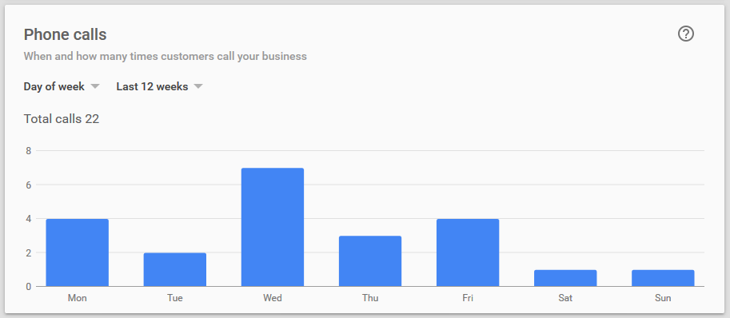
Mistake #6: You’re not adding photos to your listing.
People want to know who you are, where you’re located, and what you’re all about. By adding photos to your GMB listing, you begin to build trust with someone even before meeting them. In addition to adding your logo, include photos of:
- Your attorneys
- Your staff
- Your building (inside and out)
- You with clients (when you have their permission)
- Your team
- You in the community
Anything else that will resonate with people in a positive way.
Google has made adding photos to your GMB listing extremely easy, offering a place for each type of photo within the GMB dashboard:
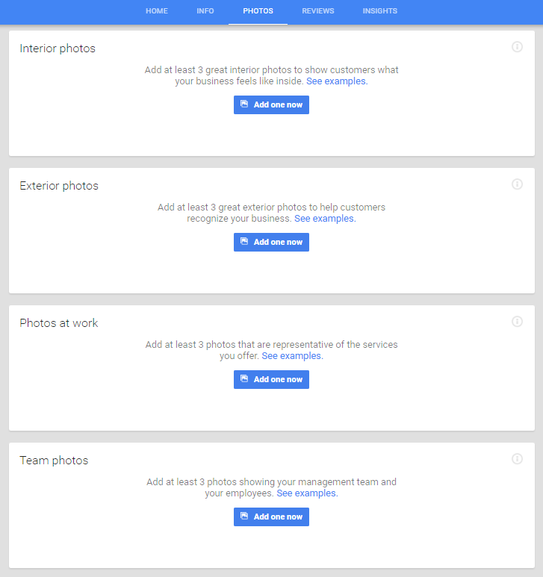
These photos appear in the “Knowledge Panel” when people search for your business name on Google:
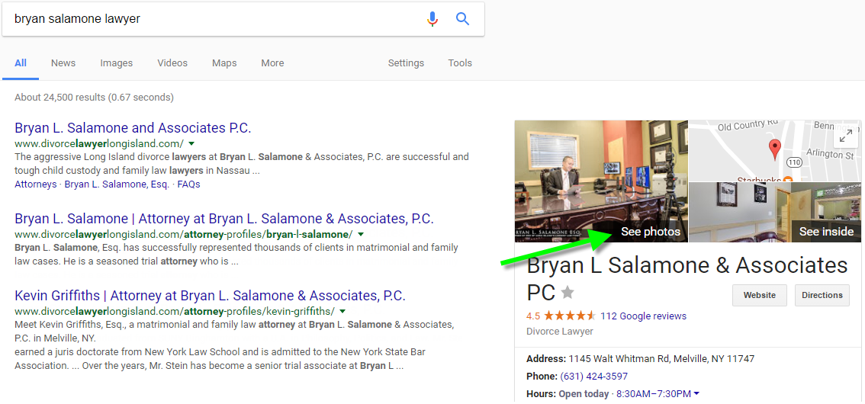
A user will be able to see all the uploaded photos if they click on “See photos.”
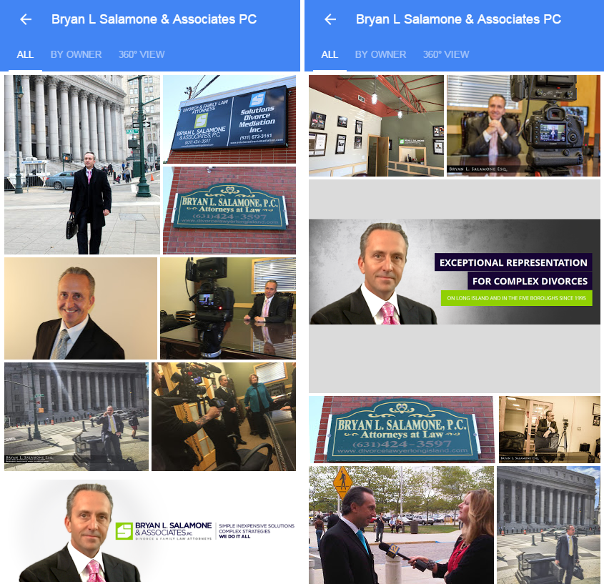
Sometimes, these photos may also appear in the Google search results!
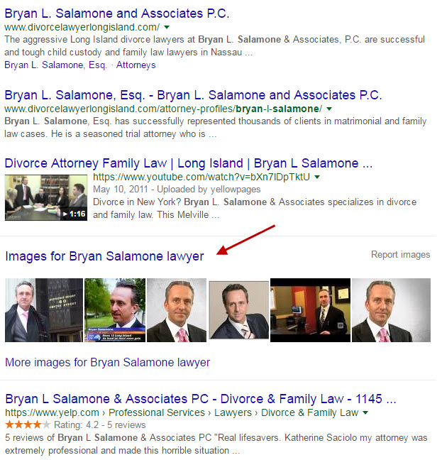
Mistake #7: Your GMB category is either wrong, missing, or you’ve added too many categories.
When you add in your specific business category, users can recognize what services you provide. However, firms often view this as a way to stuff “keywords” for their listing(s), assuming that they’ll rank for all those keywords.
By doing that, however, their business becomes misrepresented. You should only add the appropriate categories for your business. If you are a sole practitioner, you should drill down to the “attorney” categories. If you are a law firm with multiple areas of practice, than you should be listed as either “Law Firm” or “Legal Service.”
As Google suggests: Select categories that complete the statement: “This business IS a” rather than “this business HAS a.” The goal is to describe your business holistically rather than a list of all the services it offers, products it sells, or amenities it features.
Another mistake is having the wrong category on your GMB listing. If you’re a divorce lawyer, you don’t want to be listed as “Divorce Service,” unless you provide mediation.
Google already has a ton of information about your business, and for the most part, knows what you do. Not following the category guidelines can raise a red flag, get you suspended, and harm your business. Think of categories as a way to reinforce what your business does; they let the searcher know that right away.
Mistake #8: You’re not getting reviews.
Google won’t penalize you for NOT having reviews, but Google will reward you FOR having reviews. The reason people search for attorneys online is because they obviously need legal help, and they don’t already have someone to turn to. So, how are they going to trust you? Or more importantly, how are they going to choose you over the attorney down the street?
It all comes down to reviews. Consumers want to know what people who’ve used your services think of you: Are you reasonably priced? Do you offer personalized attention? Do you return calls promptly?
Mistake #9: You haven’t added in your location attributes.
Last month, Google enabled business owners to add attributes to their GMB listing via the dashboard. These attributes tell customers even more about your business. Things like “has wi-fi” or “family-friendly” are examples of local attributes. However, those don’t apply in the legal vertical, and aren’t even available yet to you.
Recap
One of the first things you should do is to claim your GMB listing. After that, make sure it’s optimized properly and is attractive to potential customers. Add your correct hours, plenty of photos, and get reviews. All of these things will help convert searchers into clients. Don’t overthink it, and don’t spam out your listing! Follow the guidelines so that your listing offers you the greatest possible advantage in marketing your firm.

Chapter #8
Google My Business Attributes
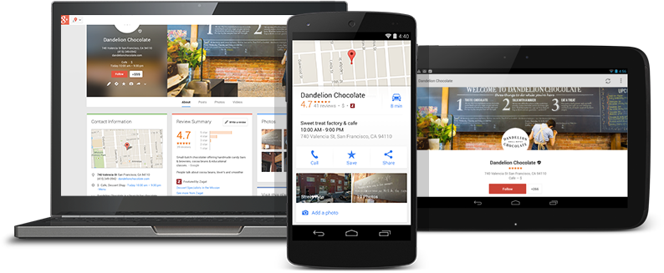
Google Attributes: What are they?
Google My Business attributes are factors or specific characteristics about a business that exist outside of the standard categories. Attributes have been used by Google to describe elements of a business such as in-store experience, wifi availability, product offerings, etc. Below are some examples of how these attributes show up in Google Maps
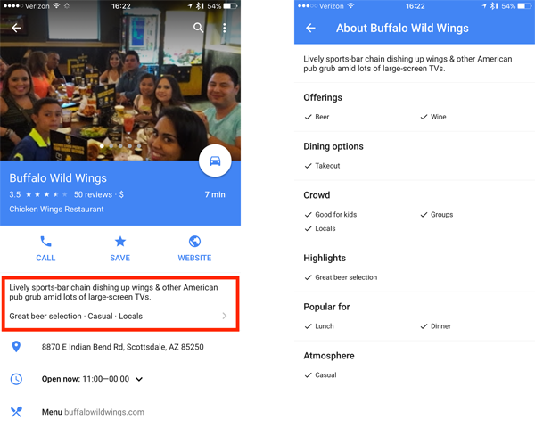
As of October 26th 2016, owner verified GMB pages now have the ability to add these custom fields into their listings for greater visibility on Google Maps. Previously, these attributes were only being crowd sourced by Google from users who left a review.
Google has customized these attributes by industry. Based on your business’ vertical, only certain attributes will become available to you via the bulk upload document. For example, a restaurant will have the attribute of offering “beer” while a bank can have the attribute of offering a “drive-up ATM”. Currently, some industries have been allotted more attributes than others.
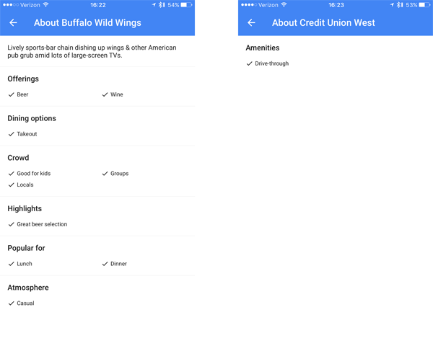
How do they affect your business?
These attributes are making Google Maps results even more customized. This allows businesses to highlight their best qualities in comparison to the competition. Google has organized attributes by breaking them into sections such as:
- Offerings (Pick up, Drive-Thru, etc.)
- Crowd (Family Friendly, Private Dining, etc.)
- Highlights (Great Happy Hour, Lots of TVs, etc.)
- Popular For (Nightlife, Lunch, Business Travelers, etc.)
- Atmosphere (Casual, Noisy, etc.)
Google takes these attributes and creates a description for you. This description is one of the first things a consumer will see when viewing your GMB listing.
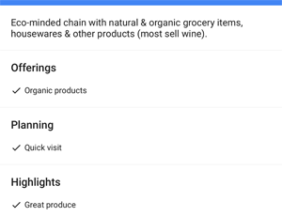
What should you do?
The best way to take advantage of these new attributes is simple. Log into your GMB dashboard and make sure your listings are up-to-date. There will be a message at the top of your dashboard explaining the new attributes. In addition, most of your GMB listings will show updates for this new feature.
IMPORTANT: You can only add in attributes through the bulk upload feature, so your dashboard will need to be bulk verified.
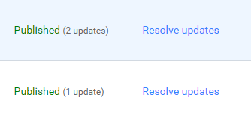
If Google has not updated your Google My Business dashboard with attributes yet, don’t worry. Google is slowing rolling out this new feature, and it may take some time for it to take effect on your listings based on your industry / vertical.
Chapter #9
Google My Business Listing Guide For 2018
Different types of Google My Business listings
There are three types of GMB listings:
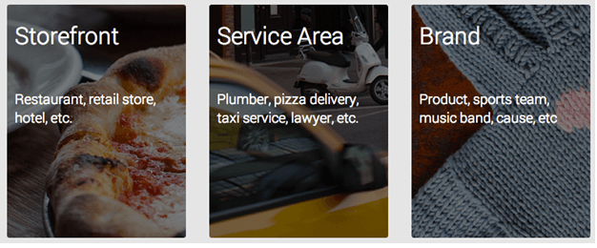
- Chain - Storefront locations of the same brand
- Service area - No storefront, but provide services to an area
- Different brands - Locations that don't share a brand
Once a listing is created, it needs to be verified by Google. Remember, Brand type is applicable if the business location is global.
How to create a Google My Business listing?
You need to have:
- Google Account
- Business NAP Details: Business Name, Address and Local Phone Number for verification
The steps to create a Google My Business Listing
- Go to Google My Business Listing Page
- Start a Listing. Verify if your business listing is already not added
- In order to qualify for a local business listing in Google, your business must meet provide your business info? And then your business basic details
  - Business Name
  - Country / Region
  - Full Address
  - City
  - Pin code
  - State
  - Business Phone number
  - Category of your Business
  - Select Service Areas
  - Provide additional information (hours of operation, payment options, photos, videos) before you are promoted to submit
  - Verify your info and submit. Listing can be verified through the following methods:
  - Postcard
  - Phone
  - Email
  - Instant verify
  - Bulk verification
In case, there are listings less than 10, PIN is sent via postcard on the physical address. Bulk verification is available for listings more than 10. SMS and phone call verifications are also available for listing verifications.
Once your listing is live it can be appear at several places: via Google search in Knowledge Graph, Google Maps, Google+
How to appear for local searches like “Pizza store near me”
There is a sub-type of service area GMB called hybrid service-area business. These businesses can show their storefront addresses and pinpoint a service area on Google My Business. Once this listing is live, the business starts appearing for relevant searches by potential customers within their service area.
If a business serve customers at your address and want to set up a service area, your business location should be staffed by your team and should be able to entertain customers during the specified working hours.
What can you do with Google My Business Listing?
Now that you have your GMB listing, this is what you can do next:
- One dashboard for all your business information updation: The GMB listing is used to power information inside Google search, Google Maps and any other relevant Google product. GMB acts as a resource centre and offers a dashboard for your business information. Google picks up this listing information to display via knowledge graph.
- Manage your information: Manage your business contact details (business name, email id, contact person, local phone number, address and URL) from here.
- Add photos of your business: Photos can be of products, clients, office interior, office exterior, employees, team, customers, facilities, store locations.

- Google reviews: Monitor your reviews and respond to your customers’ queries.
- Expand Your Network: By sharing news, events, updates you can broaden your network and connect with your fans.
Integration with Google Adwords Express
AdWord Express offers online advertising for one who wants to manage the adwords campaign alone. If you are looking to increase your site traffic and get more transactions on the website locally or globally.
Common Problems that you might encounter with GMB and their Fixes
Google My Business Listing adhere to high quality information and violation of the guidelines might lead to account suspension.
Some of the common problems that you might face with GMB are below:
- Multiple listings for same business - If there are duplicate listing and listing with incorrect information has more reviews, please request Google to transfer reviews to correct listing and then merge the two listings. Please note service area businesses cannot have multiple listings.
- Third Party business image or info appearing in own listing – Check which site image is coming an how, there is option to report error to Google.

- Not able to verify listing – individual or bulk – It could be ownership issue, Business NAP information is not correct, not using real name, address pointing wrong, incorrect contact info. For bulk verification official domain name email id is needed. Use local phone numbers only.
  - Listing Not approved – Find out possible causes
  - Listing Got removed – Multiple listings exist
  - Account Suspension – prohibited content use or other factors listed below.

- Listing deleted or permanently closed but not removed from search result – Deletion does not mean removal of listing but it stops appearing under your listing and will be available for claim. Permanently close is to show user that location is no more available but does ensure removal
- Existing listing claim issues – Read the possible reasons for listing not appearing
- Ownership transfer issue – lack of information of primary owner, proper steps not followed
- Listing businesses sharing same business NAP – When multiple businesses run at the same address, name and local phone number should be different.
- Deleting business listing permanently: Even though the listing is closed it might appear for search, but its chances to appear in local search would lower.
- Limitations of verification: 8 times you can request to verify a listing thereafter you will not be able to verify the listing. So, you would be required to delete ad create a new one.
- Issue claiming an existing listing : To claim unverified listing is easy, follow Google verification process outlined here. But, in case you want to claim a listing that someone else has claimed so you cannot claim and need to contact google to claim your business listing.
Individual practitioners are not allowed to create multiple listings to cover all of his or her specializations
- Ownership Transfer Issue: Suppose your business key person is leaving the company for any reasons, don’t forget to transfer ownership. Check these steps.
Let me know in case you want us to evaluate your Google My Business presence by creating a complementary and obligation free audit report for you.
Let us look at this table to go through the roles and capabilities of GMB users.
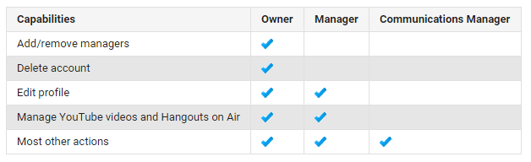
Owners and primary owners have the same capabilities, but a primary owner can't remove themselves from a listing until they transfer their primary ownership to another user. Owner can add or remove listing owners. With Business account you can add users to manage your business listings.
What should you do?
With customer behaviour firmly biased towards mobile, Local SEO is as important as regular SEO. Google My Business (and equivalent channels like Bing Places, Twitter Cards…) are important new platforms that need to find place in your marketing plan.
For Google My Business listing, you will get your business listing live and can rank higher if you adhere to quality guidelines. It is all about being real, present for your customers with consistent and accurate information.
Chapter #10
Improving Your Local Google Presence With Reviews
If you have worked through the guide so far, you’ve realized how important it is to not only have a local listing set up on Google but you also know how crucial it is to have these listings set up properly so that viewers are engaged and they actually want to check out your business.
Here, we will find out how to get the most out of your listing and create ways that will get customers in the door or at least on the phone with you.
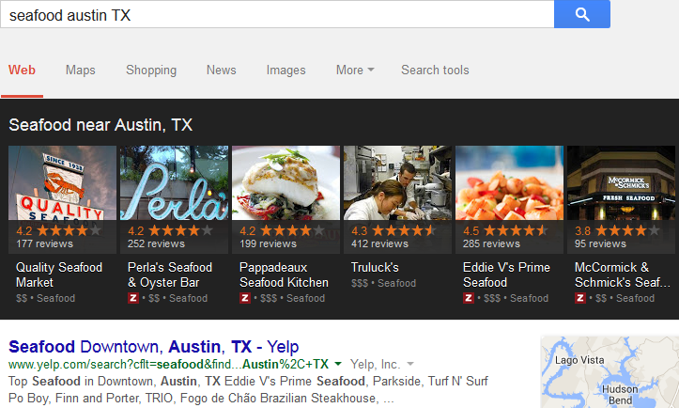
How to Beef Up Your Google Local Listing?
Today’s example is mainly going to do with the sea food industry.
The amount of reviews that Google users have left for your business directly effects how prominently your company shows up in the local results box. In layman terms, without a high number of great reviews your business is likely to be buried deep within the results, and out of the public’s eye.
However, with this being said, don’t think that just because you have a ton of reviews will be the holy grail to getting your company listed first. Comments left by people who have used your service or visited you need to be genuine and informative for other viewers to gauge your credibility off of, not just reviews like “A+!” and the other sorts of stuff that is frustrating to see.
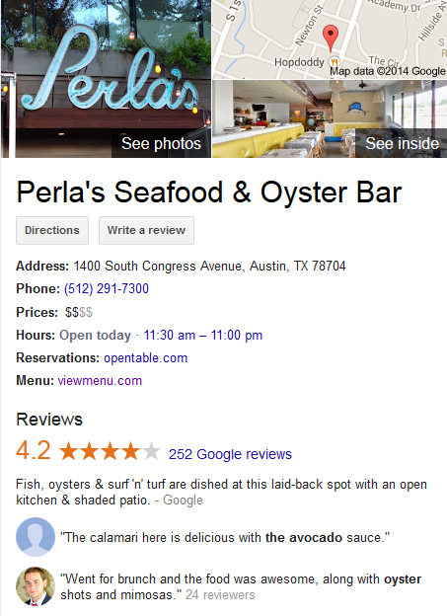
Securing Reviews to Give Your Business Authority
Quite often businesses ignore the importance of incorporating their customer’s reviews into their local listing strategy. Reviews are the greatest way to figure out how great a company really is, or isn’t for that matter.
Going back to our seafood restaurant example, what’s one of the first things you check out when researching a new place to eat at? Chances are you will be looking at the reviews to find out how other people enjoyed the food, the drinks and the atmosphere and then use those reviews to determine if you will give the restaurant a chance.
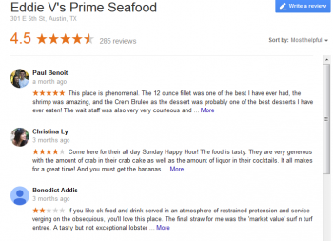
How Can We Get These Reviews?
For customers, leaving a review on Google may not always be a simple process. If you think about it, most of your reviews are going to come from point of service, meaning that your clients are often leaving reviews on their cell phones or tablets and not from the comfort of their home. This results in reviews that may be short and abrasive if they are poor in nature or short and lacking information if they are a good review.
To combat this issue you need to implement ways that will get your customers to leave you reviews after they have had time to fully take everything in and they are in a comfortable place to do so.
For example, the driving school No Yelling likes to distribute flyers to their students after each lesson that encourages them to leave a review. Not only do they ask kindly for a review but also the flyer lays out the process step by step to make it easy and understandable for the student to do so.
Using Services to Manage Your Company’s Reviews
Another problem you may be running into is converting the great in person reviews from your customers into reviews that make it online for the world to see. Fortunately, there are many services available that can remedy this problem for you. Get Five Stars is a great tool you can use that allows you not only get your reviews published online more easily, but also see them beforehand.
Because you are able to see your customers’ reviews before they get posted to the internet review systems you are able to fix any problems that may have surfaced during your service. By doing this you are able to connect directly with your unsatisfied customer and find out what made their experience unpleasant, giving you a chance to fix it and gain back their trust.
Not only does this bring a customer back into good standing but also removes a potentially bad review from your online presence and replaces it with a great review about how you went above and beyond to fix the problem they had with your company.
Approaching the Bottom of the Local Listing Iceberg
That’s a wrap for this regarding how to use the new Google My Business tool to promote your business online. Now that we’ve covered a majority of the local listing iceberg we will discuss the final tips and tricks that give our local listing the buoyant force it needs to float along in the next lesson.

Chapter #11
Citations, Review Sites & Tracking
In this lesson, we are going to cover how to use citations on other review sites to help improve your Google Local rankings as well as tracking these rankings to keep on top of your influence online.
Let’s take an example of the SERPs for seafood in Austin, Texas that not only includes the local listing results but the organic results also featured review sites like Yelp. Sites like Yelp are a great way for not only getting reviews and publishing your company to the local public but these search results can also increase the visual real estate of the query result, meaning that your company shows up more than just once and is likely to be more prominent than your competitors.
What Citations Are and How to Use Them?
On the internet a citation is known as a mention of your business’s address, phone number and name, otherwise known as NAP for short. Often times these mentions will not have a link to your site but instead will just be a text entry. Even though these entries aren’t a link it is commonly believed that Google still treats these mentions as authoritative and thus you should make sure you are listed in your relevant directories.
There are tons of citation sites you should double check to make sure your listings are accurate. Below, are 12 of the most popular citation platforms that you must be checking to ensure that your business is cited correctly:
- Yellow Pages
- Manta
- Yelp
- Better Business Bureau
- Indeed
- Super Pages
- Facebook
- Yahoo Local
- Angie’s List
- Urbanspoon
- White Pages
- Dex Knows

- Using Data Aggregators
Data aggregators allow you to submit your information to their directory and they will in turn supply this data to the citation sites we just discussed, saving you the time of having to manually enter the information yourself.
The four powerhouses that control this data are Localeze, Infogroup, Acxiom and Factual .
Each of these aggregators updates and confirm business data in their own ways. For example, Localeze uses geo-coded tags for latitude and longitude locations of businesses to create local listing information while Infogroup likes to make phone calls to businesses and personally make sure that the business details they have are correct.
- Tracking Citations
Once you have all of your citations squared away it is equally as important to track them to ensure that remain current and up to date.
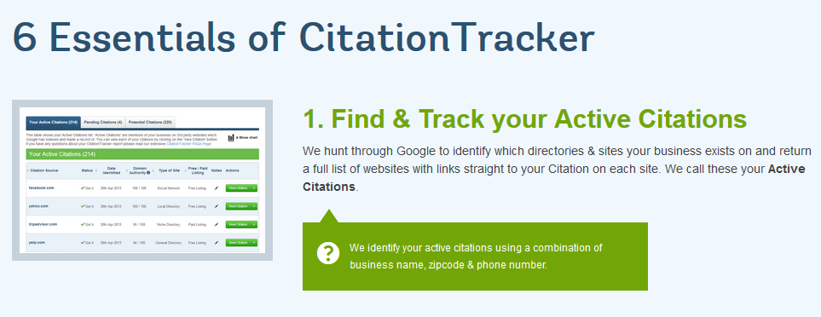
Citation Tracker is a tool that allows you to find the citations that your business already has. Additionally, you can use the tool to spy on your competitors to see where they are getting their citations from as well.
ABC Seafood Company
123 Sea St
Austin TX 90210
An important thing to remember when using citation tracker or other citation finding tools is to make sure that the NAP information matches with the NAP information you have provided to Google or other local listings. Often times mismatched information is not regarded as valuable and can easily be passed over by a search engine bot that is crawling the web for your information.
- Using Review Sites to Increase Your Company’s Visibility
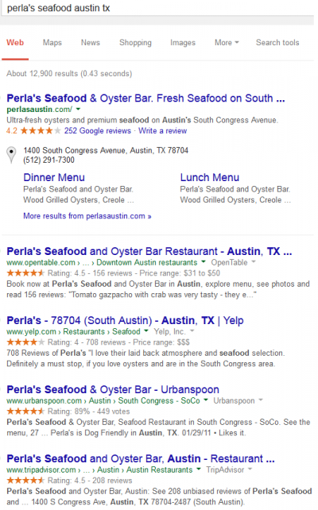
As mentioned before, review sites like Yelp and Oyster are not only great for getting your business out into the public spotlight with the help of your clients’ reviews but they are also great for increasing the real estate you get in organic search results.
As seen to the left, by getting your company registered on the available public review networks you are able to effectively capture the entire search query result page, leaving no room for your competitors to even get their name in. Pretty cool, right?
If you were in a super competitive industry with lots of local followings this strategy is an easy solution to knocking your competitors down a peg, leaving your brand’s name the only one customer will ever see.
- Building Links
Often times it is best to use an agency to handle the outreach and negotiation of links but they are still important for local businesses. However, there are a few relatively easy ways that you can try to get more links pointing to your site:
  - Sponsoring Local Events
Renting out or donating some of your office space for local events. Help out other local businesses when they are in need.
By sponsoring local events you improve your chances of getting other local resources to talk about you online, thus generating a natural link that is great for your website. Additionally, by helping out your community in general you can get other locals to talk about you online and making references to your website and all of the great things you have done to help out around town.
  - Marketing Great Content
Producing engaging content for your target audience can also aid in the effort to gain links for your website. People who find your content informative and fun to read will often link your page because they want to share the information with their friends and viewers, meaning that your website gets even more exposure. In turn, this also helps to beef up your local listing profile as links begin to trickle in and your listing becomes more authoritative.
If you were the proprietor of a seafood restaurant you may write an article for a local publication regarding sustainable fishing and how your business helps contribute to this cause. Or, if you own a construction company you might write about the steps you take to use green building materials to help better the environment.
- Tracking Your Business’s Local Rankings
The last thing we’re going to cover in this is regards tracking your company’s rankings over time to ensure that you don’t drop out of the field. Perfecting your local listing is not just a one-time deal. You have to occasionally check your rankings and determine if action is needed to ensure that you stay on top, or, if you have dropped down, devise a new plan to get you back to the top.
How to Check Your Rankings?
There are many different ways you can go upon checking your rankings for different search terms. A more manual approach would involve typing in your perceived search queries into Google and visually checking how your company is ranking in the local listings.
A second method would include using an SEO tool (there are many, many choices available and they all essentially do the same things) that automatically scrapes Google for your rankings and displays them to you in a report. With such a tool you can easily see any drops or bumps you get in your listing and adjust your plan accordingly.

Chapter #12
Tracking Google My Business Traffic Data

We all know that Google My Business is used to improve your company’s local search presence and attracting new customers via reviews, photos, company information and much more. We can all agree these are very important, but how do you know if this is attracting more customers to your website?
Learn how to start tracking your company’s Google My Business traffic data and see how much of an impact it has!
Why You Should Track Google My Business
There is no doubt that having a properly optimized Google My Business listing is the lifeblood of any local based company. Even though this is the case, unfortunately 99.9999% of all Google My Business listing owners or managers do not track their traffic and data.
Tracking your company’s Google My Business data is an often overlooked aspect of any local seo campaign. We all know the value of Google My Business listings, but how much value does your l really offer?
The key metrics that stand out the most are click through rate and conversions.
- Google My Business Listings Have a High Click Through Rate (CTR)
If your listing is displayed in the local pack, you can assume that you will get clicks. There are click through rates for listings that have been as high as 7.3% over a 90 day span. While this is a great CTR, the average is about 5%.
- GMB Listings Convert Very Well
Along with a high click through rate, Google My Business listings have a very high conversion rate. There have been conversion rates as high as 16.40%, but on average, somewhere around the 6% range is more common.
This shows that Google My Business listings are extremely valuable if you are showing up in the local pack from both a click through but as well as a conversion standpoint. If you are a company who worries about leads and have a focus on converting site traffic, Google My Business is one of the best avenues for local lead generation.
How to Track Google My Business Traffic To your Site?
Tracking Google My Business traffic is actually very easy, and there are a couple of ways to do this.
The first method is by create a custom UTM tracking code. The other way to track data is done within your GMB dashboard.
If you create the UTM code, this enables you to track data in both Google Analytics and Search Console. In my opinion, UTM code tracking is the best way to see any traffic coming to your site from your Google My Business listing. As long as you set everything up correctly, this is a very effective way to track data.
Tracking your listing within your GMB dashboard is also a great way to track traffic data. In my opinion though, unless you are ok with being handcuffed by very limited data, this the lesser of the 2 methods mentioned. Even though this gives a limited amount of data, this is easier for small business owners to use.
No matter which method you use to track your Google My Business data, it is always important to see where your traffic is coming from, and how it as increased over time.
- Using UTM Codes To Track Google My Business Traffic
When it comes to accurately tracking your Google My Business traffic, you need to set up UTM tracking codes. This is very easy to do and requires no prior knowledge of any sort of coding or programming whatsoever.
For those that do not know what a UTM tracking code is, they are simple codes that you attach to the end of a URL in order to track a source, medium, campaign name, campaign term, and campaign content. This enables Google Analytics to tell you where traffic is coming from as well as what campaign directed the traffic to your site.
Having UTM url’s in GMB listings is a must for any company that relies heavily on tracking every aspect of their marketing efforts, or for an seo consultant who gives detailed reports to their clients.
Creating UTM Codes
To create a UTM code you can use the Google Developer Tools Campaign URL Builder and you will come to a screen as shown below. All you need to do is simply put in the right information into the appropriate fields.
- Website URL – Put the root URL or whatever page you are linking to in your listing.
- Campaign Source – I use “local” as the source since Google My Business is part of my local SEO campaign.
- Campaign Medium -Use “organic” since GMB listings are from organic searches.
- Campaign Content - you can use or whatever you think is appropriate here.
Once you input these values into the appropriate fields, your new tracking URL will auto populate in the box at the bottom.
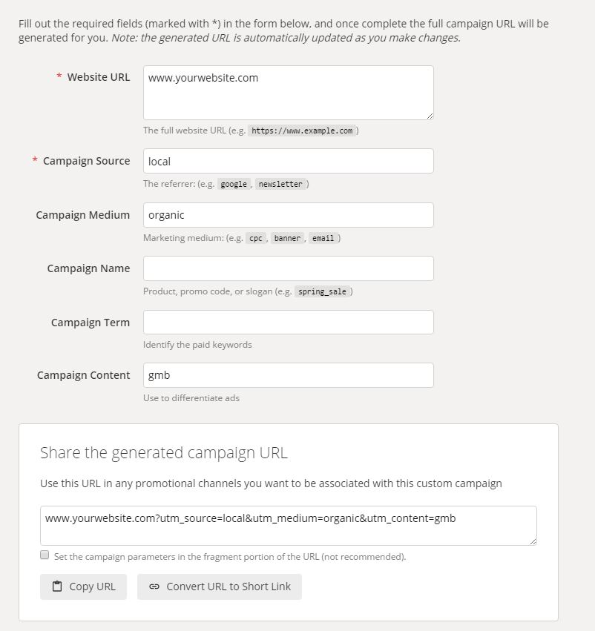
After your new URL is created, you have the option to keep it as is or shorten it. If you decide to shorten it, then it will appear like below.
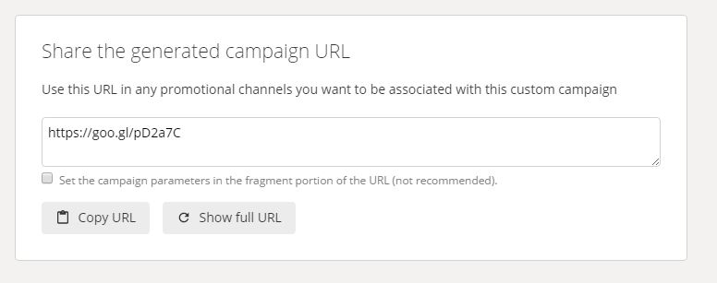
Note: If you have a company with multiple locations and have more than one Google My Business listing, you can put that data in the Campaign Name section. This will allow you to create as many different URL’s as needed. For example, if you own a small chain of restaurants, you can use each location’s city as the Campaign Name.
- Adding UTM Tracking URL To Google My Business Listing
Once you’re all set with creating your new UTM tracking URL, you need to add it to your listing. To do this, simply go to your account dashboard and select either info or edit. This will bring up a new screen with your company information.
Scroll down to find the existing URL and replace it with the new UTM tracking URL.
Once you add the new URL to your listing, you can refresh the page and it should be live.
- Setting Up Tracking Within Google Analytics
Once your new URL is live on your listing, you need to now be able to track it in Google Analytics. The way to do this is by creating a new segment within your GA property. To create a new segment you simply click “Add New Segment”.
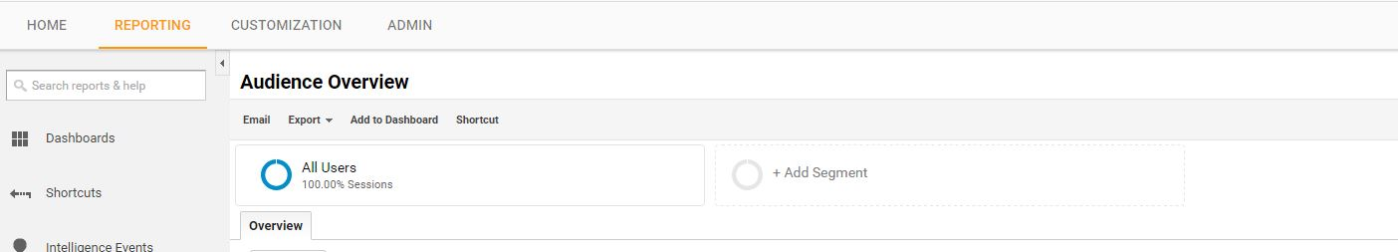
This will bring up a list of all existing default segments. Once this appears, select the red “+ New Segment” button. This will display the screen shown below.
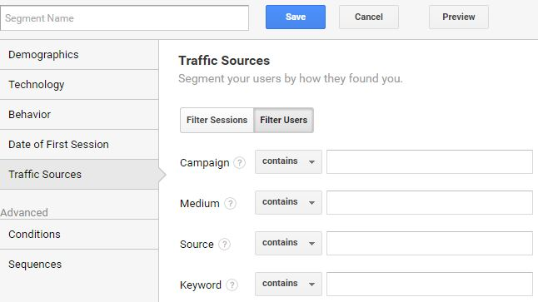
Choose “Traffic Sources” on the left and this will display the correct info that needs to be filled out.
When filling out the fields, all you simply do is match the sections to the same as when you created the UTM tracking code.
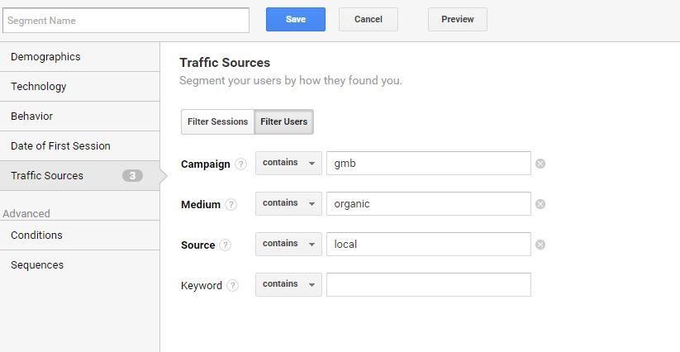
After this is done, you can start tracking you Google My Business Traffic!
- Seeing Google My Business Traffic In Google Analytics
Now that you have correctly setup your Google My Business tracking within Google Analytics, you need to be able to start seeing the traffic. There are a couple of ways you can do this. The first method is to look within Source / Medium. To get here, simply go to Acquisition > All Traffic > Source / Medium.
Once you get here, you will see a similar layout as shown below. Here you can see that local / organic, which is what we made our Google My Business UTM tracking URL source and medium set as displaying. This signifies that your listing is generating traffic.
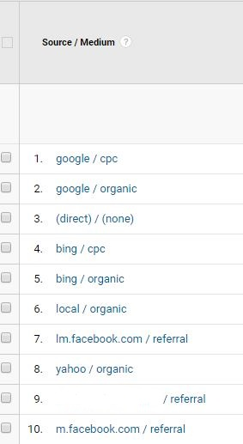

Another way to see your Google My Business traffic within Google Analytics is to look at the campaigns. To see this, all you simply do is look under Acquisition again then Campaigns > All Campaigns. This will display the following screen.
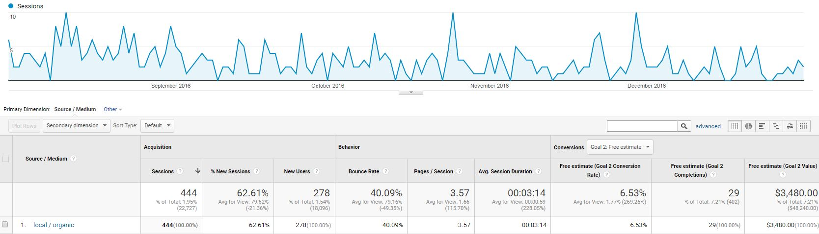

Google My Business Data in Google Search Console
Being able to see Google My Business data in Google Search Console is a great way to see even more data. This to me is a great way to determine how many users come to the site from my listing, what keywords are used to find the listing, and how many impressions my listings get.
As you can tell from this screen grab, this GMB listing generates a great deal of traffic for this site. Filter it for Clicks, Impressions, and Click Through Rate (CTR). This data shows that this Google My Business listing has a very high Click Through Rate (5.44% over a 90 day span).
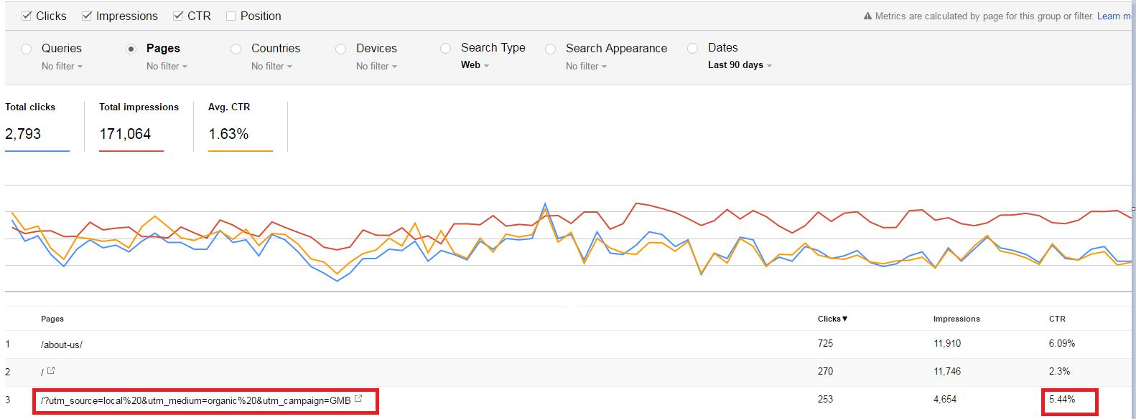
Conclusion:
Anyone who works with Google My Business listings in any capacity should start tracking traffic data. We all know that GMB is very valuable to any business, but now you can realize how valuable. Next we will cover how to interpret the traffic insights data in the next chapter.
Chapter #13
How to interpret GMB Traffic insights?
Google My Business Insights Tracking
Within Google My Business, there is its own unique analytics tracking called Insights. Some of these categories were updated in August 2016.
These metrics give details about the current performance of your listing such as:
- How customers are searching for your business
- Where they view your business on Google
- How they interact with the listing
- How often they look at driving directions
- The amount of phone calls
- The number of photos you have and how many times they have been viewed
These metrics are very easy to see and are found on the top of the Google My Business dashboard and titled “Insights”. For the basic user, these are very useful in determining how well your listing is performing in search, and how often users interact with it.
How Customers Search For Your Business
Of the numerous insights metrics, the how customers search for your business is one of the most useful. This bit of data shows if your listing is coming up via searches for keywords related to what you do or if users search for your brand.
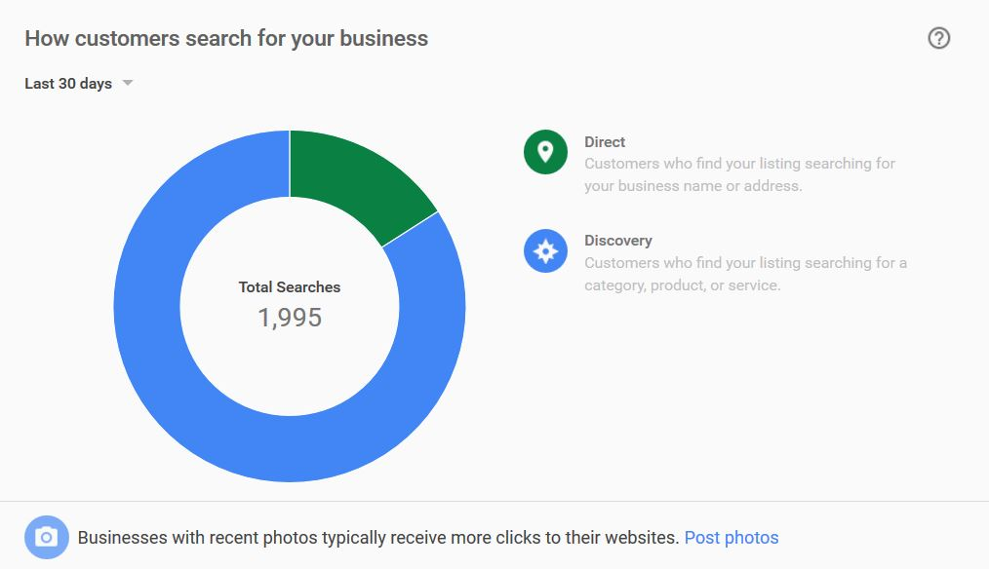
Google My Business has two ways of looking at traffic, and they are called Direct and Discovery. This data shows impressions rather than clicks
Direct traffic is defined as “customers who find your listing searching for your business name or address”. These listings often show up when users do a search and only your listing is the one displayed in the SERP. You can attribute Direct search data to other forms of marketing you are doing or have done, or even returning customers.
Discovery traffic is defined as “customers who find your listing searching for a category, product, or service”. This type of traffic is more organic and displays your listing in the local pack or map. You can attribute this traffic source directly to your SEO campaign.
Where Customers View Your Business On Google
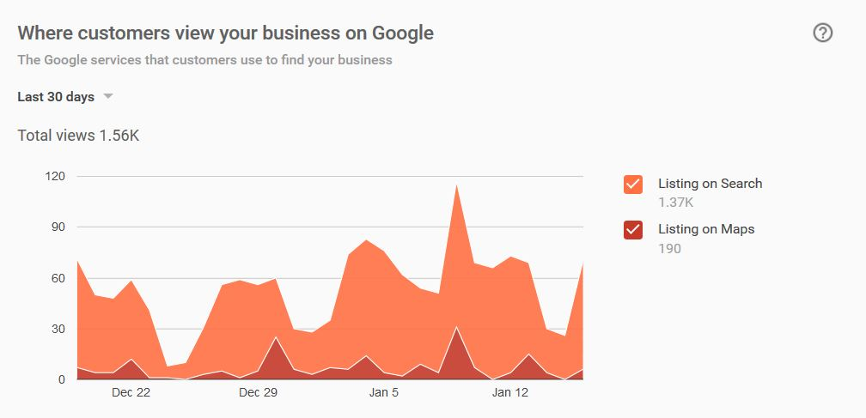
The where customers view your business metric is another very useful bit of data. This shows whether your listing is seen on the search results page, or on maps. This gives you a good idea of how your target audience is finding your listing.
Customer Actions
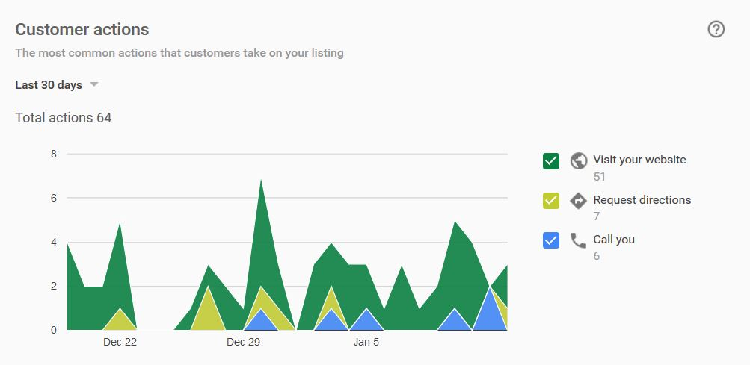
The Customer Actions data shows how users interact with your listing. This shows the most actions that users can take once they are on your listing.
- Visit Your Website – this data tells you how many times users visited your site after interacting with your listing.
- Request Driving Directions – how many times users looked for directions to your business.
- Call You – the amount of phone calls your listing has generated
Based on your business, some of these metrics would matter more than others. For example, if you manage a local Dunkin Donuts, you might focus more on the request directions data.
If you operate a home services business, you might focus on the amount of calls or clicks to your website that could convert into leads.
Driving Directions Requests
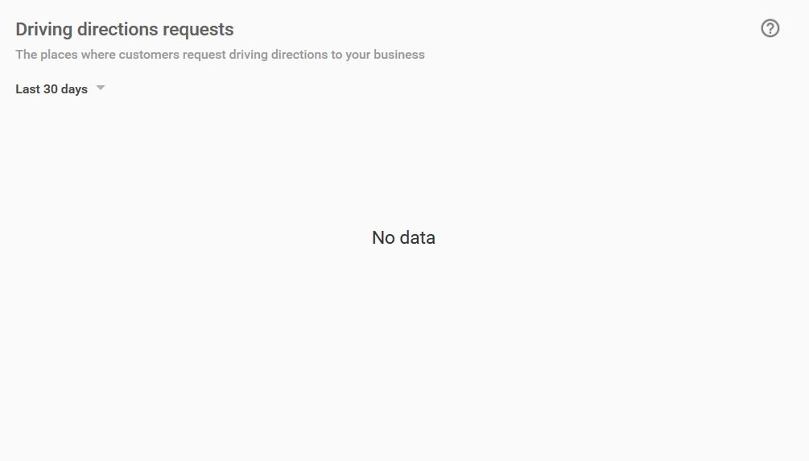

This section shows the amount of times users looked for driving directions to your location. Depending on what type of company you have, you may have many or none. For example, you will get more data as a restaurant or service business at a single location like a gas station compared to a company that has a service area (ie. plumber).
Note: the chart above with no data is from a service area business that does not serve customers at their location.
Phone Calls
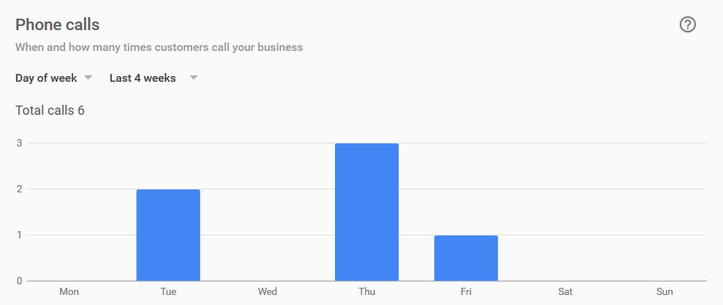
Similar to the Customer Actions, you can see the number of phone calls here. The thing that stands out here is that the numbers here won’t match the numbers under Customer Actions. The reason for that is because you can only see 4 weeks (28 days) of data compared to 30 days in the Customer Actions section.
Photo Views
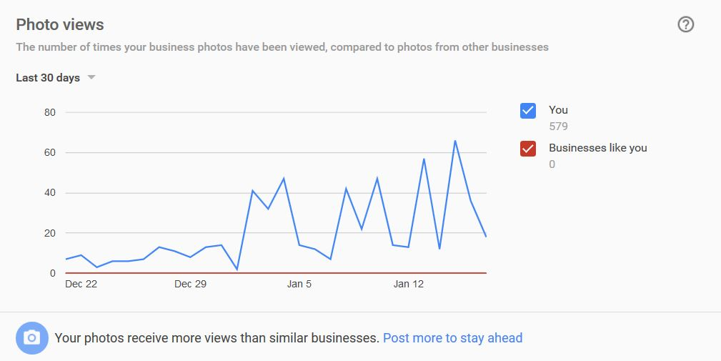
In the Photo Views section, you can see how many times users have looked at photos associated with your listing. This is a great indication that you have quality photos on your Google My Business listing. Google recommends that you upload quality photos to your listings, and if you do this, you will see an increase in photo views.
Photo Quantity
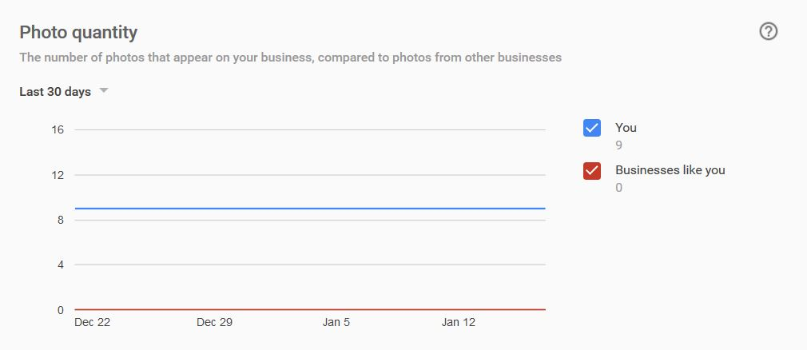
The Photo Quantity insight tells you the number of photos currently associated with your listing. As mentioned in the Photo Views section, it is always recommended to upload quality photos and update them often.
Another great feature about this is that you can see the amount of user generated photo content added to your listing. This is great for business where customers take a lot of pictures of your products or services.
In Conclusion
After you start tracking Google My Business Listings, you will quickly learn that properly optimized listings have a high click thought rate when they are displayed. Not only that, they generate a good amount of conversions according to Google Analytics.
Start tracking your Google My Business traffic, and start seeing results today, folks!

Chapter #14
All about using the Google My Business API
Google My Business API
The Google My Business Application Programming Interface (API) is designed for developers who represent large, tech-savvy businesses and third parties. Developers looking to write applications to manage Google My Business data should consider signing up for the Google My Business API.
How you can use the API?
Using the Google My Business API effectively requires technical savvy and coding knowledge. With the API, you can manage locations at scale with actions like:
- Editing location information
- Reading and responding to customer reviews
- Updating menu details like photos, descriptions, and prices
- Viewing insights for locations
- Subscribing to push notifications for new customer reviews
- Creating and updating posts
- Adding photos
- Providing additional attributes for locations (like a hotel's amenities, or a restaurant's menu URL)
- Inviting and removing managers
- Managing service-area businesses
Get started with the API
To get started with the Google My Business API, follow instructions on the Google Developers site.
Pre-requisites:
Before you can start coding your first client application, there are a few things you need to do, if you haven't done them already.
- Get a Google Account
You need a Google Account in order to create a project in the Google API Console. If you already have an account, then you're all set.
- Try out Google My Business
This API documentation assumes that you've used Google My Business, and that you're familiar with web programming concepts and web data formats.
If you haven't used Google My Business, then try out the user interface before starting to code.
- Create a project in the Google Developers Console
Before you can send requests to the Google My Business API, you need to use the Google API Console to create a project, and activate the Google My Business API. To create a new project, do the following: -
- Go to the Google API Console. Click Create project, enter a name, and click Create.
- Request access to the API
- You must complete the following steps to enable your project and access the API.
- Go to the Google API Console and select the project you created for use with Google My Business to find the Project ID.
- To determine your project ID, do the following:
  - Go to the Google API Console.
  - Find your project in the table on the list-of-projects page.
  - The project ID appears in the Project ID column.
  - Complete and submit the access request form.
  - You will receive a follow-up email after your request has been reviewed.
  - After approval, return to the Google API Console and enable the Google My Business API for your project.
  - Activate the API
Note: The Google My Business API will not appear in the following steps until your project has been white listed. The API will only be visible in Google API Console to the users whose Google Accounts were submitted in the access request form.
To enable an API for your project, do the following:
- Open the API Library in the Google API Console. If prompted, select a project or create a new one. The API Library lists all available APIs, grouped by product family and popularity.
- If the API you want to enable isn't visible in the list, use search to find it.
- Select the API you want to enable, then click the Enable button.
- If prompted, enable billing.
- If prompted, accept the API's Terms of Service.
- Get an OAuth 2.0 client ID
- Because your app will access protected (non-public) data, you will need an OAuth 2.0 client ID. This lets your app request authorization to access your organization's location data on behalf of your app's users.
Open the Credentials page in the API Console.
If you haven't done so already, create your OAuth 2.0 credentials by clicking Create credentials > OAuth client ID. After you've created the credentials, you can see your client ID on the Credentials page. Click the client ID for details, such as client secret, redirect URIs, JavaScript origins address, and email address.
Learn REST basics.
Conclusion:
The Google My Business API lets developers build applications that interact directly with their business location information on the Google My Business server. With these applications, chains and third parties can more efficiently manage their large or complex Google My Business accounts.

Chapter #15
Case Studies
Millions of people use Google My Business across the world. Discover some of their inspiring stories.
Success Story #1: Jackalope Brewing Co.
Two friends open a Nashville brewery and find success by connecting with people who share their love of craft beer. Jackalope uses Google to help customers find them and their new brews.
Check out the full success story here - https://www.google.com.hk/intl/en/business/success-stories/#?modal_active=ss-yt-lhYIuiHOD1s
Success Story #2: Otis James
One man’s love for handcrafted items leads to a small southern shop where caps and ties are made with simple, stylish details. Google helps him bring old fashioned crafting to people all over the world.
Check out the full success story here –
https://www.google.com.hk/intl/en/business/success-stories/#?modal_active=ss-yt-W1VmT5Vlxww
Success Story #3: Faidley’s Seafood
The fourth generation of Faidley’s Seafood. See How GMB helps her preserve her legacy business and carry it forward and making a mark in this world
Check out the full success story here –
https://www.google.com.hk/intl/en/business/success-stories/#?modal_active=ss-yt-mINlZmeZkco

Conclusion
Google says 50 percent of mobile consumers that search for a local business visit it within a day of the search, and 18 percent of consumers make a purchase. Sound like something your business should be a part of? Absolutely.
With Google handling more than two trillion searches a year, and nearly half of those having local intent, it’s safe to say that having a local presence for your business is huge. And that all starts with a Google My Business listing.
Google My Business helped to revolutionize the world of local search—and the appeal of search engine optimization for small businesses otherwise unfamiliar with SEO.
Following this guide you must have understood that your local SEO is critical, even with Google My Business.
So, you should activate and maintain your My Business account, and make it awesome using the tips and tricks laid down in this guide. Hence, to get the most out your listings and to get good rankings, you must have your site in order as well. Optimize every part of it. Create local content for your chosen keyword and business location. Acquire quality local Backlinks to build up a solid link profile. Ask customers to review your business onsite or on My Business. Make sure your listing is active and attractive. Dead profiles are no good.
Hope this guide helps you benefit from the latest GMB updates and features and take your business to the next level in 2018.

